**A PROJECT REPORT**

**ON**

**SELLING FESTIVAL’S PRODUCTS ONWEB**

**AT**

**MAHENDRA MERCHANDISE**

**SUBMITTED TO**

**GUJARAT UNIVERSITY**

**FOR PARTIAL FULFILLMENT OF DEGREE OF**

**BACHELOR OF COMPUTER APPLICATIONS (BCA)**

**SEM-5 SYSTEM DEVELOPMENT PROJECT – II**

**SUBMITTED BY:**

**SAGAR JAYESHBHAI BHATT**

**AMIT DINESHBHAI RANA**

**MEET HEMANTBHAI SHAH**

**INTERNAL GUIDE EXTERNAL GUIDE PROF.BHAVIK PANDYA MR.AJAY MEHTA**

**NAVGUJARAT COLLEGE OF COMPUTER APPLICATIONS**

**ASHRAM ROAD, AHMEDABAD-380014**

**WEBSITE: www.navgujaratbca.com CONTACT NO: 079 27542859**

**YEAR: 2017-18**

Navgujarat College of Computer Applications

Navgujarat Campus, Ashram Road Ahmedabad

www.navgujaratbca.com 079-27542859

Certificate of Completion

This is to certify that Software Development Project **“Festopedia”** Is submitted to Gujarat University by:

1 Sagar Bhatt

2 Amit Rana

3 Meet Shah

They have successfully completed the project for the duration of six months (Sem-VI) towards the partial fulfilment for the award of “Bachelors in Computer Applications [B.C.A.]” in the year 2018.

This is the original work carried out under our guidance and supervision. We further certify that the details are best to our knowledge and believe that the matter presented in this project is bonafied. We appreciate their enthusiasm and dedication towards work submitted.

Best wishes for their future endeavours.

___________________ ________________________ __________________

(Internal Guide) (Hon. Director) (External Examiner)

ACKNOWLEDGEMENT

* We express our heart gratitude to a Number of people who extend their full support and co-operation in developing this project. Firstly, we would like to take this opportunity to thank our college “**NAVGUJARAT COLLEGE OF COMPUTER APPLICATIONS**” for giving us this opportunity and a platform for discovering and developing our potential, this kind of experience that we have received while making this project report is so immense that narrating that in few word is difficult.
* After putting is such a hard work we have realized that takes to work in company and do a Project. Our company **MAHENDRA MERCHANDISE** and our colleagues have been great source of help without them we were unable to do this project. Therefore our project as if a small drop of water out sea. We have learnt many things from being a part of concept family.
* After that our heartiest thanks to our internal guide as well as respected faculty **PROF.** **BHAVIK PANDYA** for entrusting upon us the responsibility and acting as ray of light in darkness. We find our self-short of words to describe our feeling for the role he played of friend, a philosopher and guide. Whenever we were in need.
* Lastly, we are thank full to our parents without their blessing, love and support. We are unable to traverse through tis most significant stage of life. And also we would like take to take this opportunity to express our regards to all friends and faculties who have helped us directly or indirectly during the execution of the project. We are privileged and thankful to all in bringing out errors and shortcoming.

Sagar Bhatt

Amit Rana

Meet Shah

**INDEX**

Sr. no Topic Page No.

1. Screen Layouts ………………………………………………....01
   1. Admin Side………………………………………………..02
   2. User Side………………………………………………….24
2. Report Layouts……...…………………………………………..51
3. Future Enhancement……………………………………..…….60
4. Conclusion………………………………………………..……..62
5. Bibliography……………………………………………………..64

# 

# 

# 

# 

# 

# 

# 

# 

Screen Layouts

1. **Admin Side :**

* **Login page validation:**

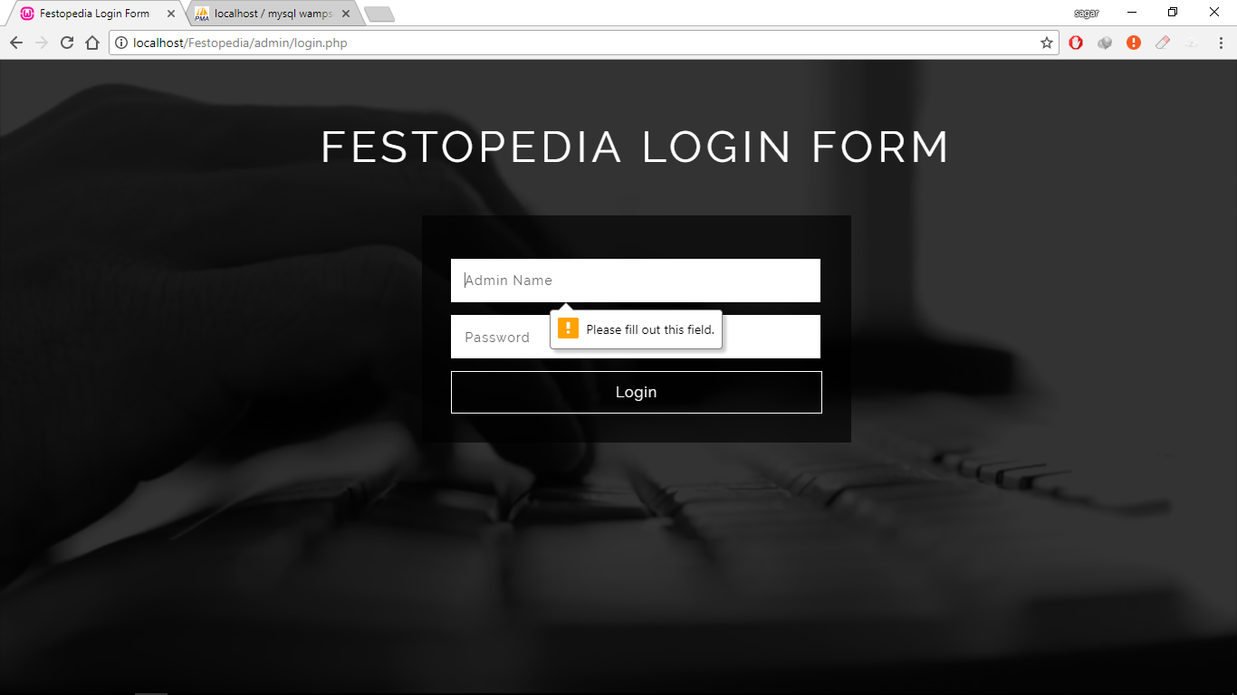

* This screenshot displays the validation in login page.
* **Login page error:**

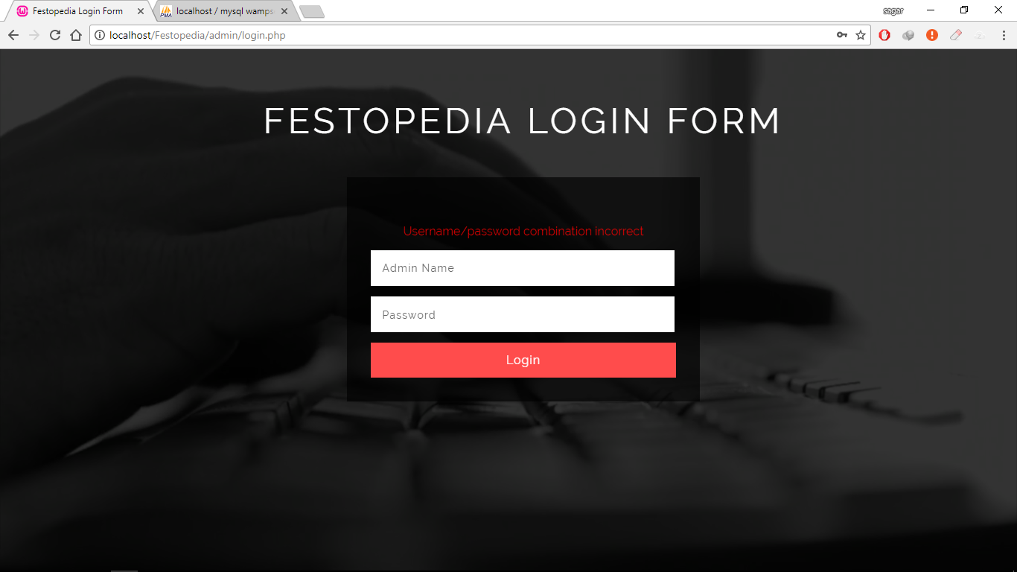

* This screenshot displays the error message, it occurs when user enter wrong information.
* **Success Login:**

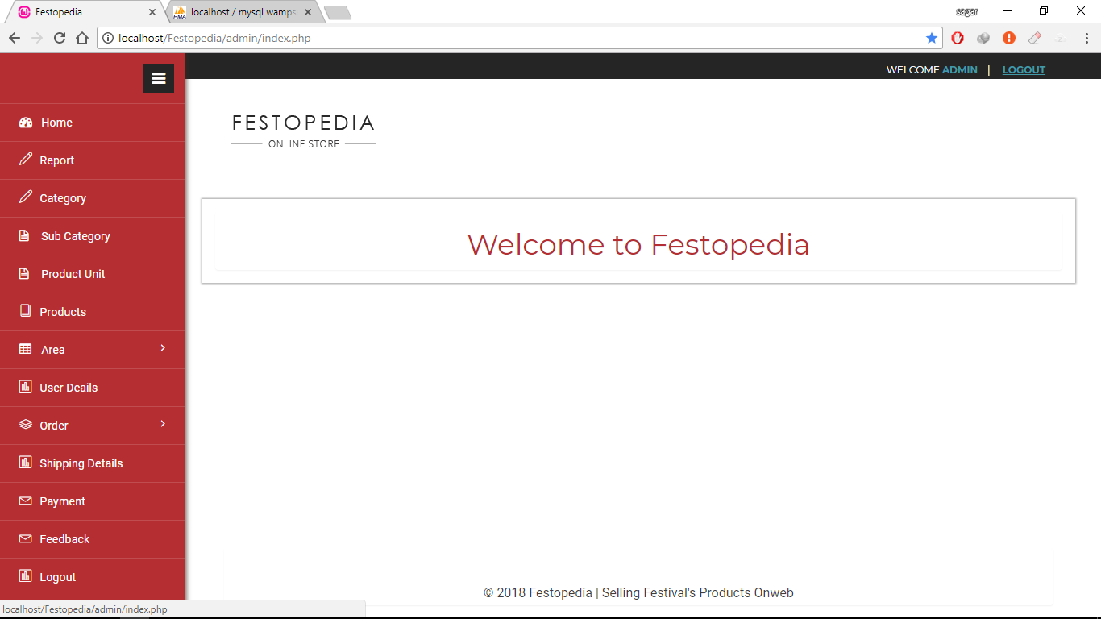

* This screenshot displays home Page. (In web application when admin enter valid username and password. and clicks on “login” button , then Admin redirect to default page).
* **All Categories:**

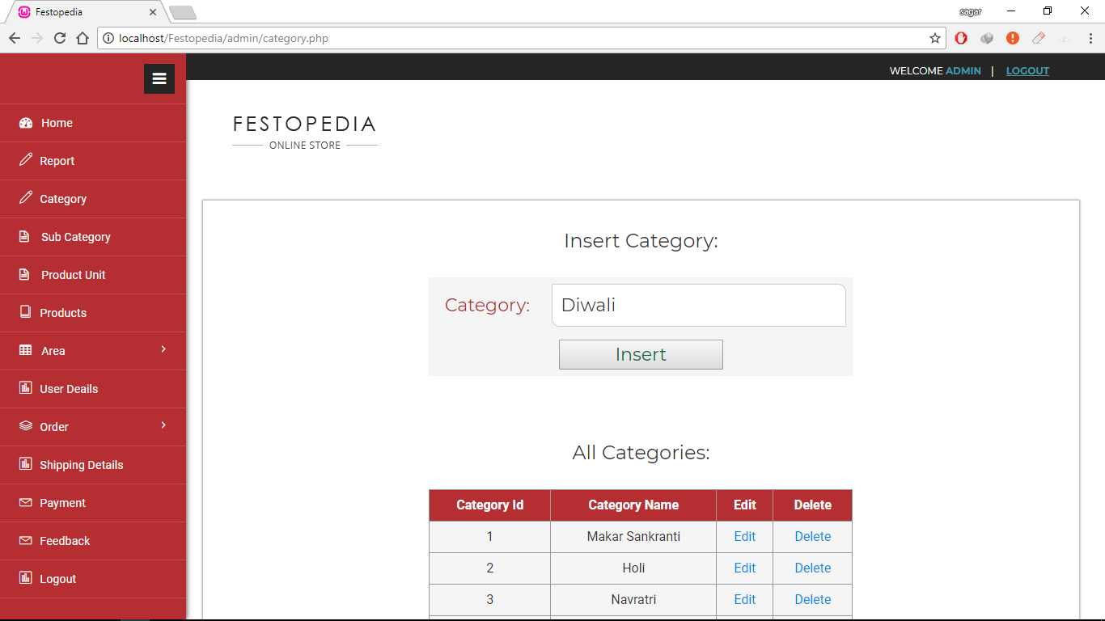

* This screenshot displays all categories and admin can insert category.
* **Validate Category:**

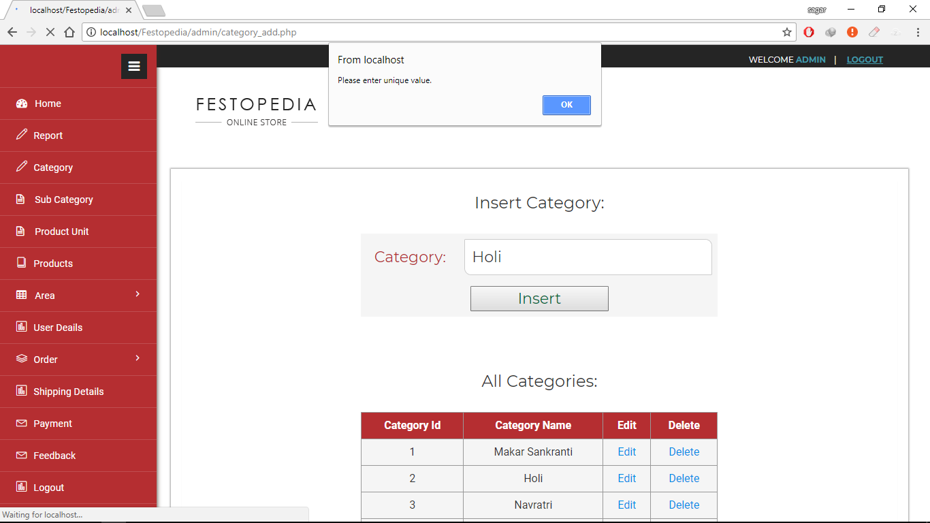

* This screenshot displays the alert message that “please,enter unique value”, It occurs when Admin enter duplicate value.
* **Edit Categories:**

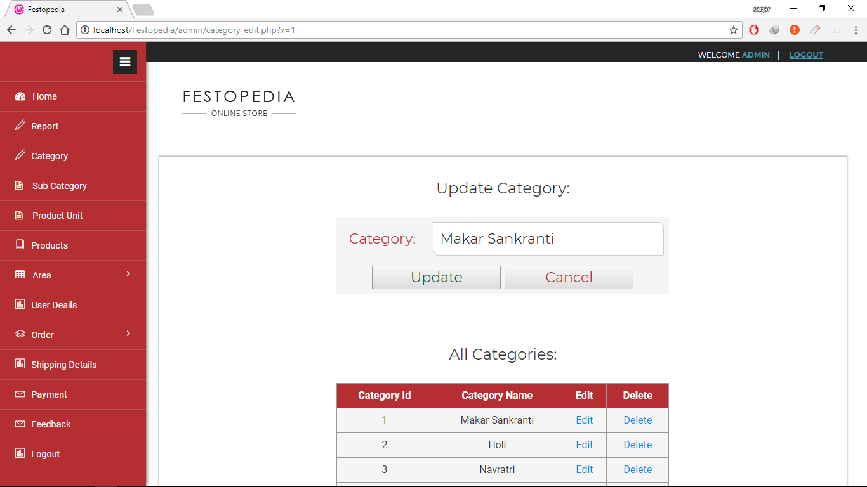

* This screenshot displays that admin can edit categories.
* **Delete Categories:**

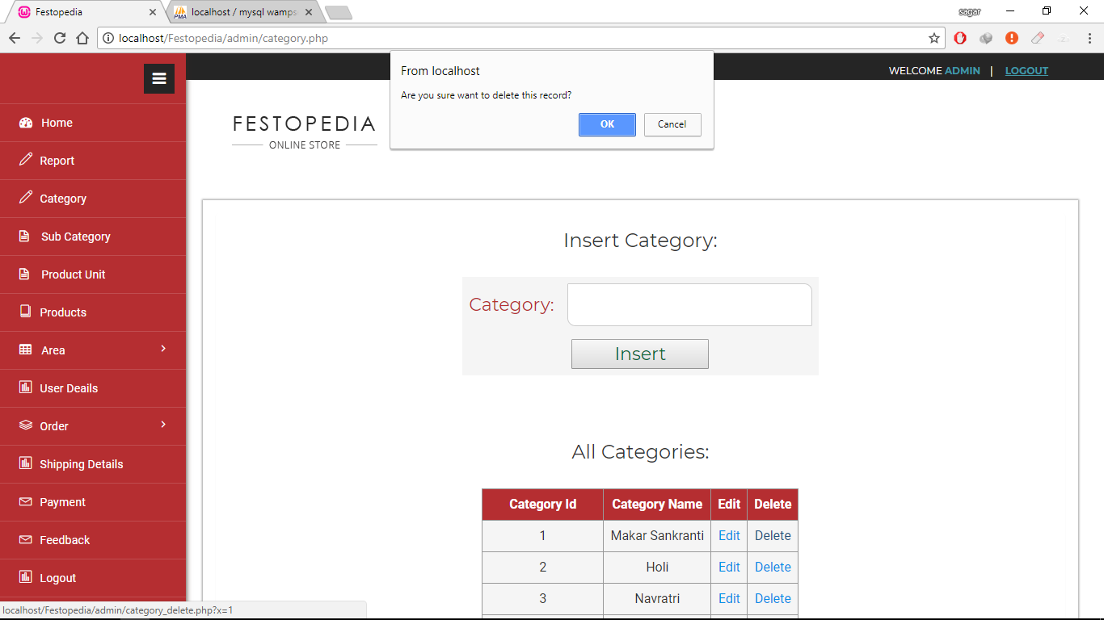

* This screenshot displays that admin can delete categories.
* **All Sub Categories:**

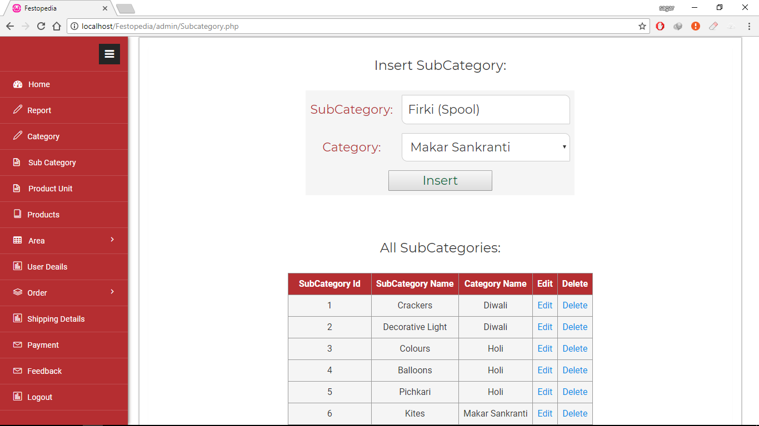

* This screenshot displays all sub categories and admin can insert a sub category.
* **Product Units:**

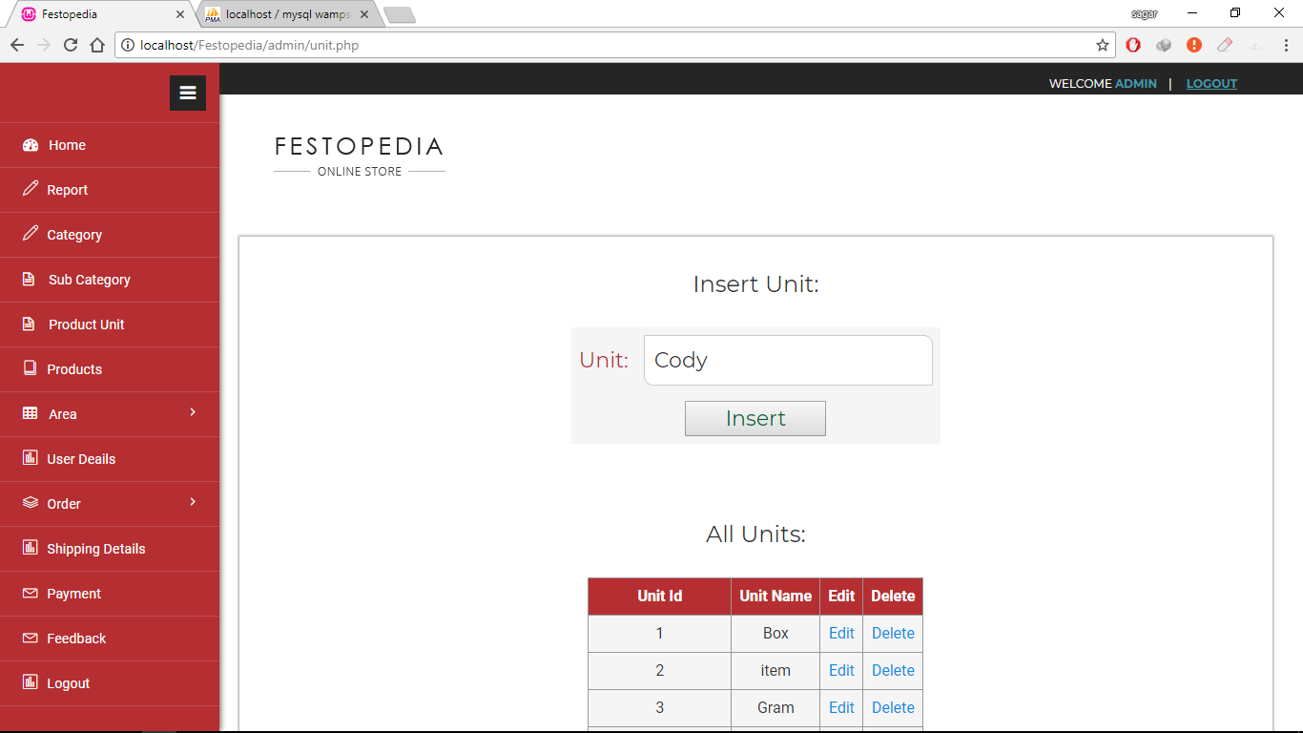

* This screenshot displays all product units and admin can insert a product unit.
* **Country Details:**

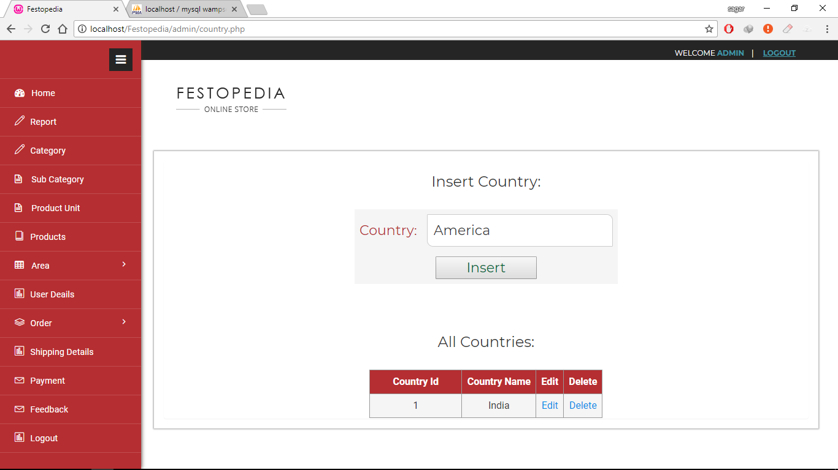

* This screenshot displays all county’s name and admin can insert a country name.
* **State Details:**

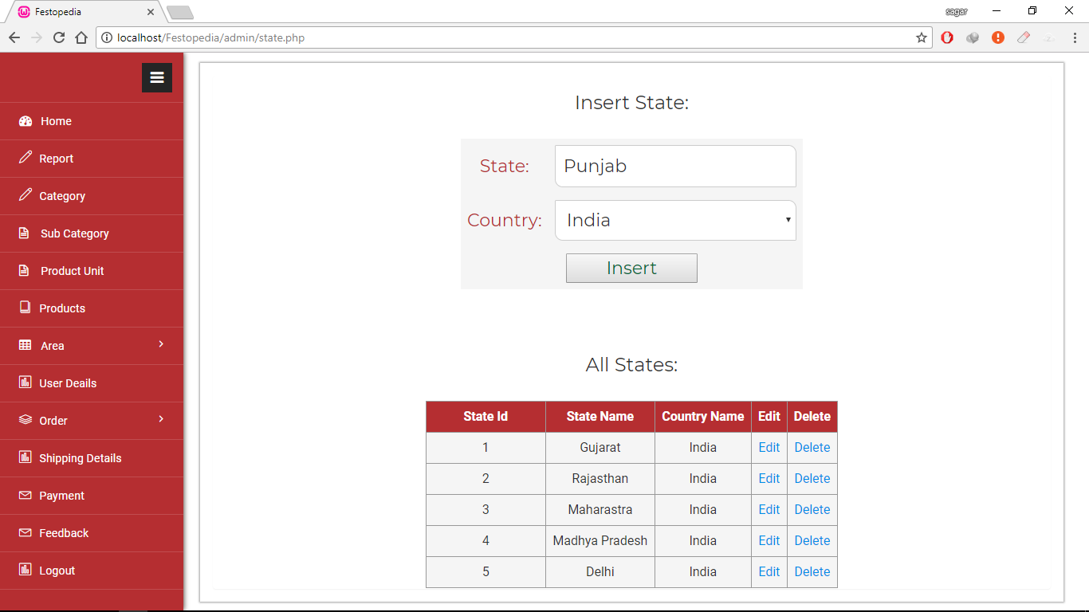

* This screenshot displays all state’s name and admin can insert a state name.
* **City Details:**

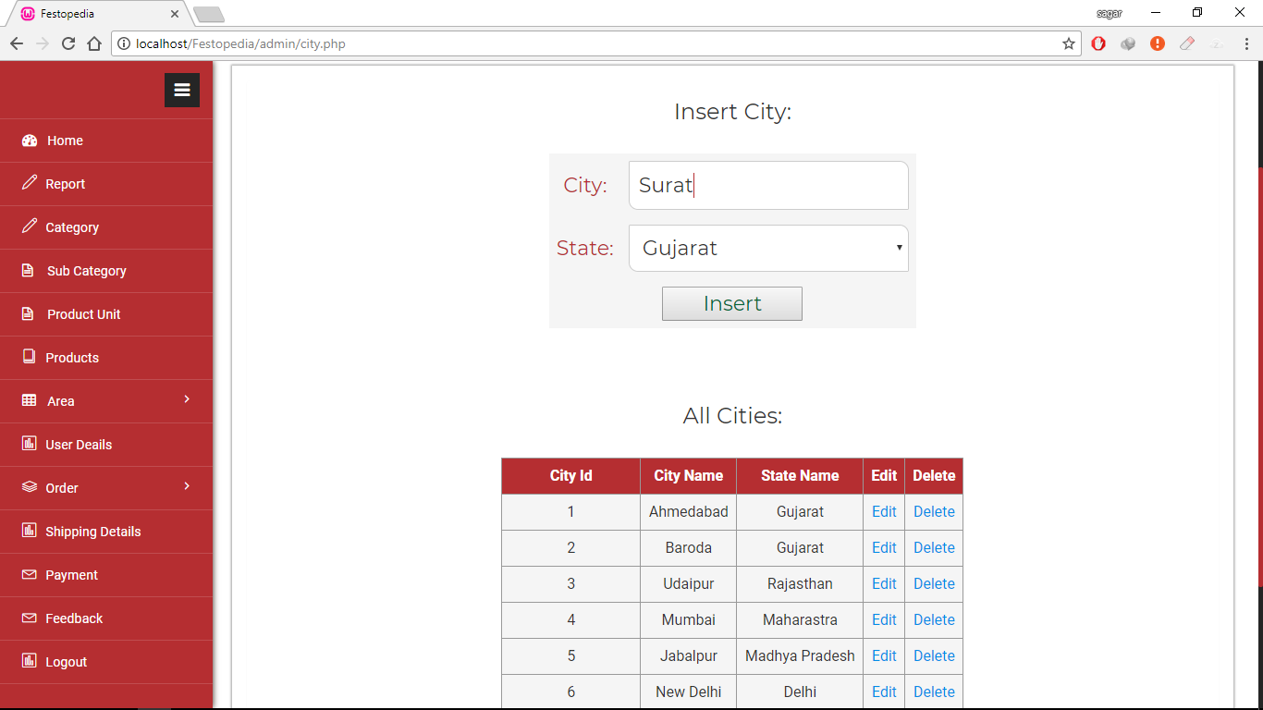

* This screenshot displays all city’s name and admin can insert a city name.
* **Product Insert:**

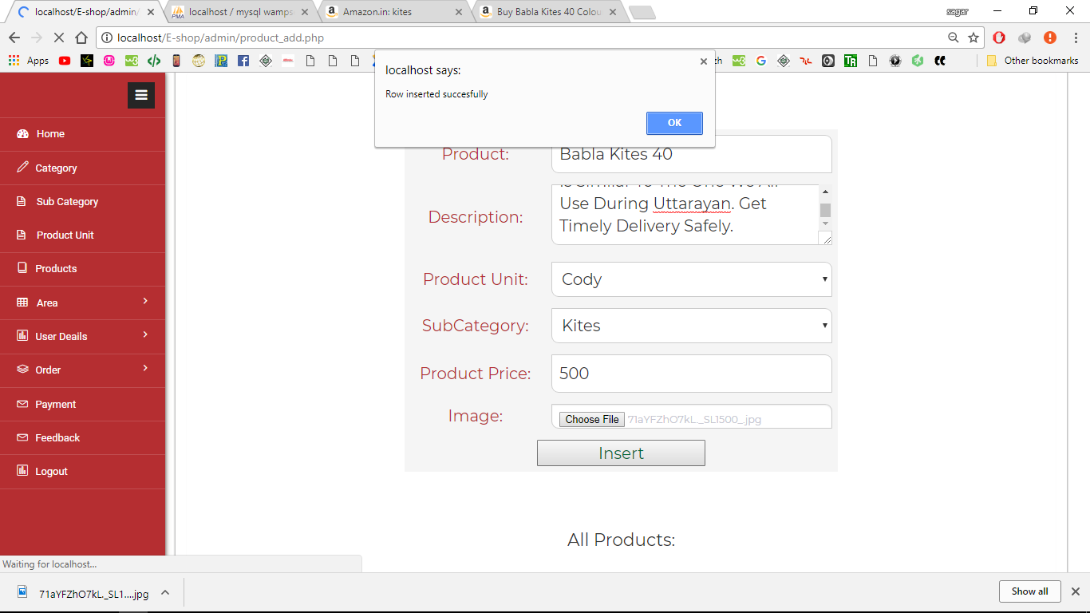

* This screenshot displays that admin can insert products and display the alert message that “Row inserted successfully”.
* **Product Edit:**

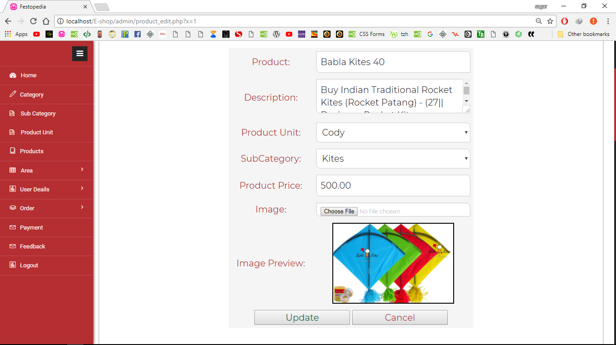

* This screenshot displays that admin can edit products.
* **Product Update:**

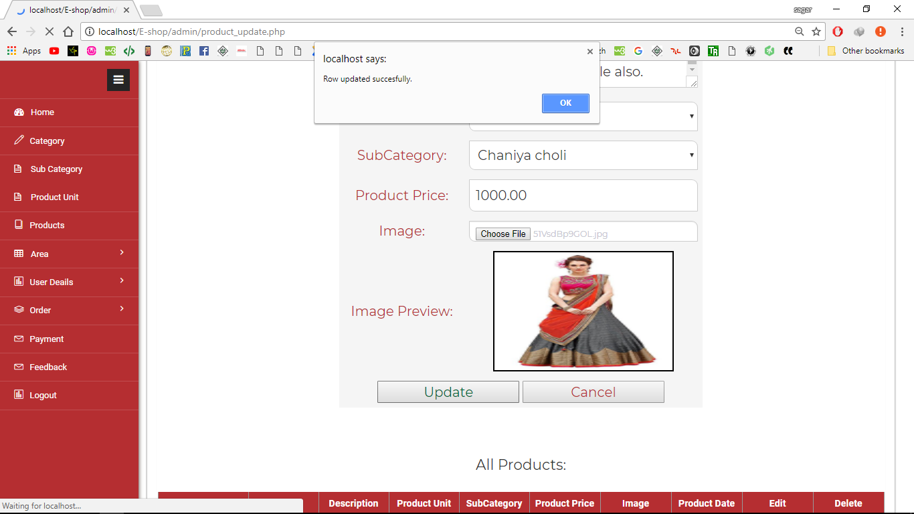

* This screenshot displays that admin can edit products and display the alert message that “Row updated successfully”.
* **Product Delete:**

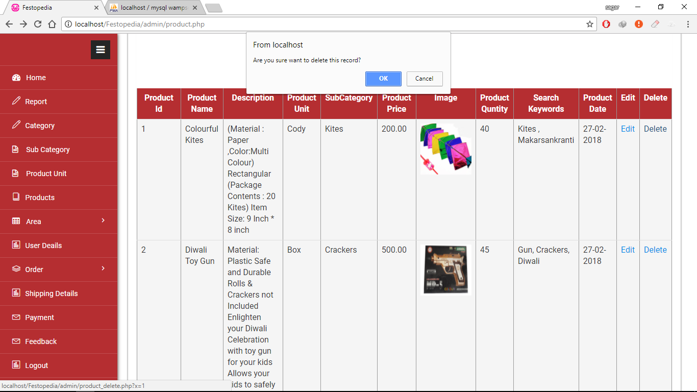

* This screenshot displays that admin can delete products.
* **Feedback Details:**

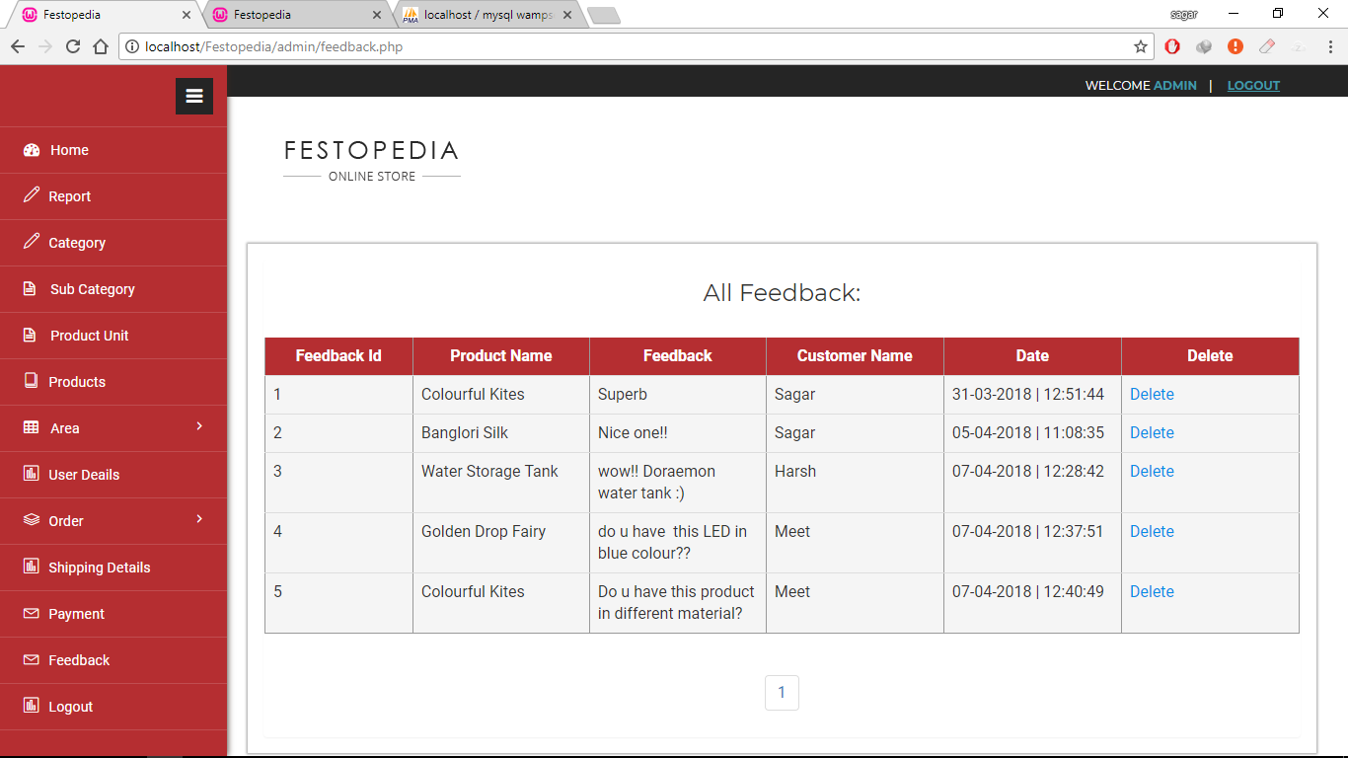

* This screenshot displays all feedback details given by customers.
* **Customer Details:**

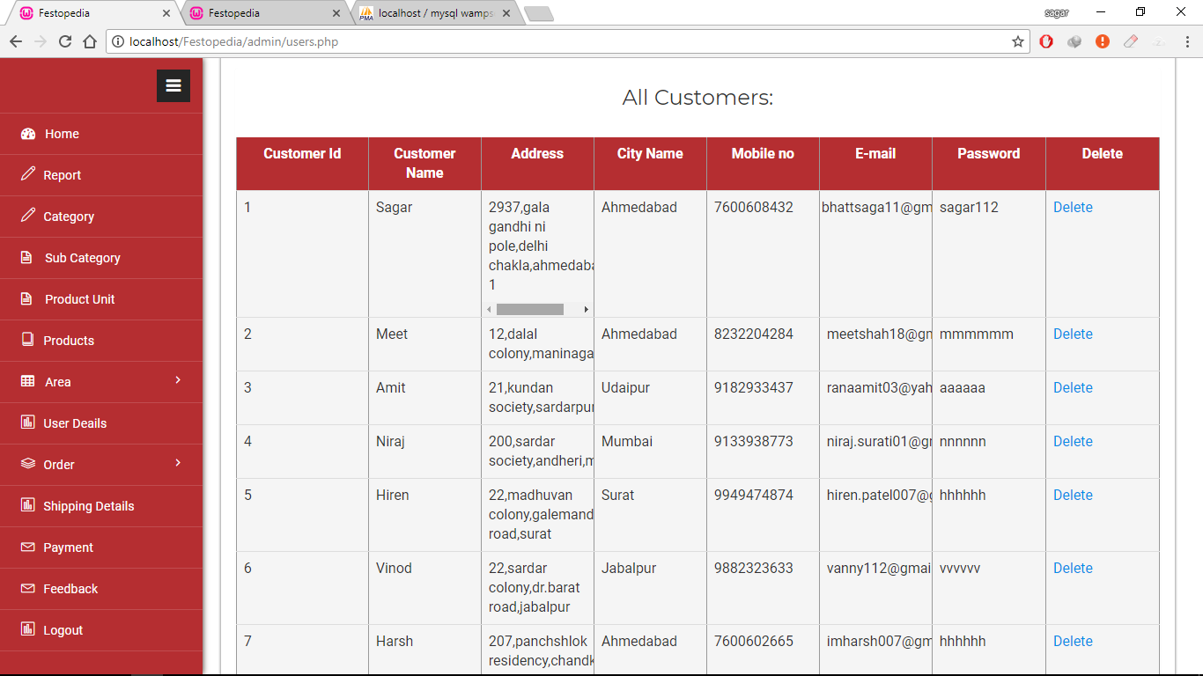

* This screenshot displays all customer details.
* **Order Master:**

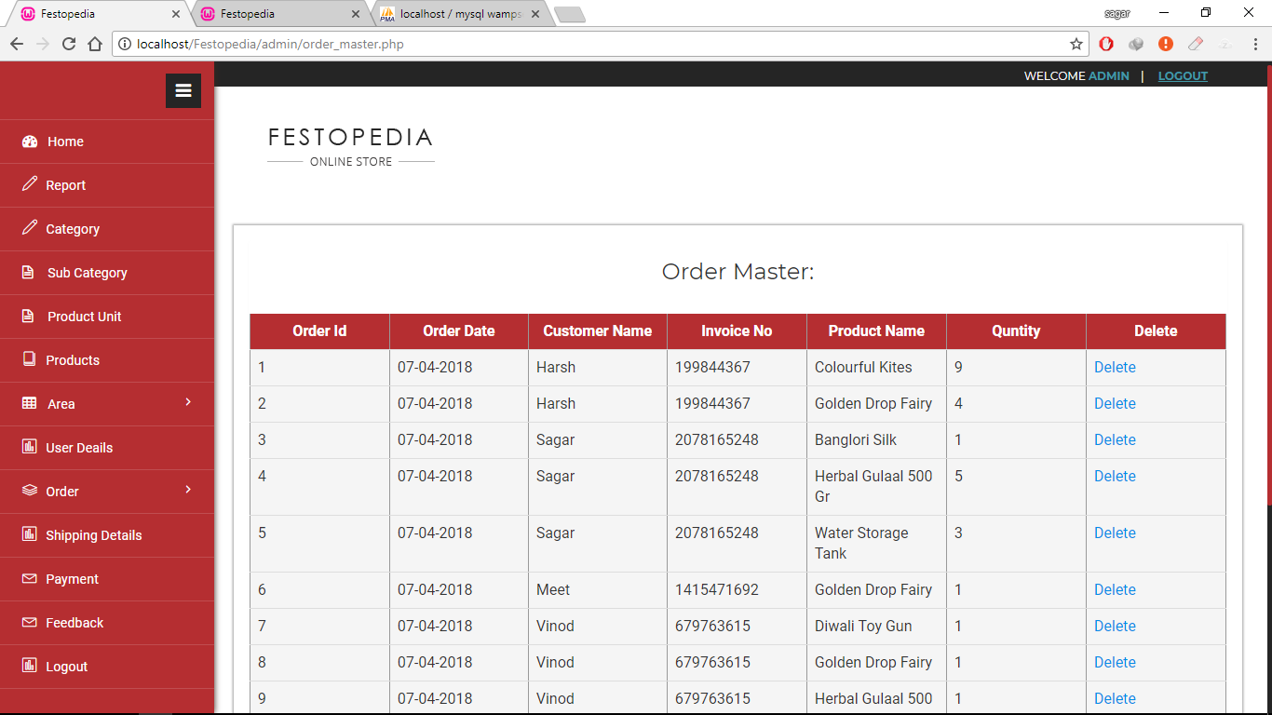

* This screenshot displays all order details of products.
* **Order Details:**

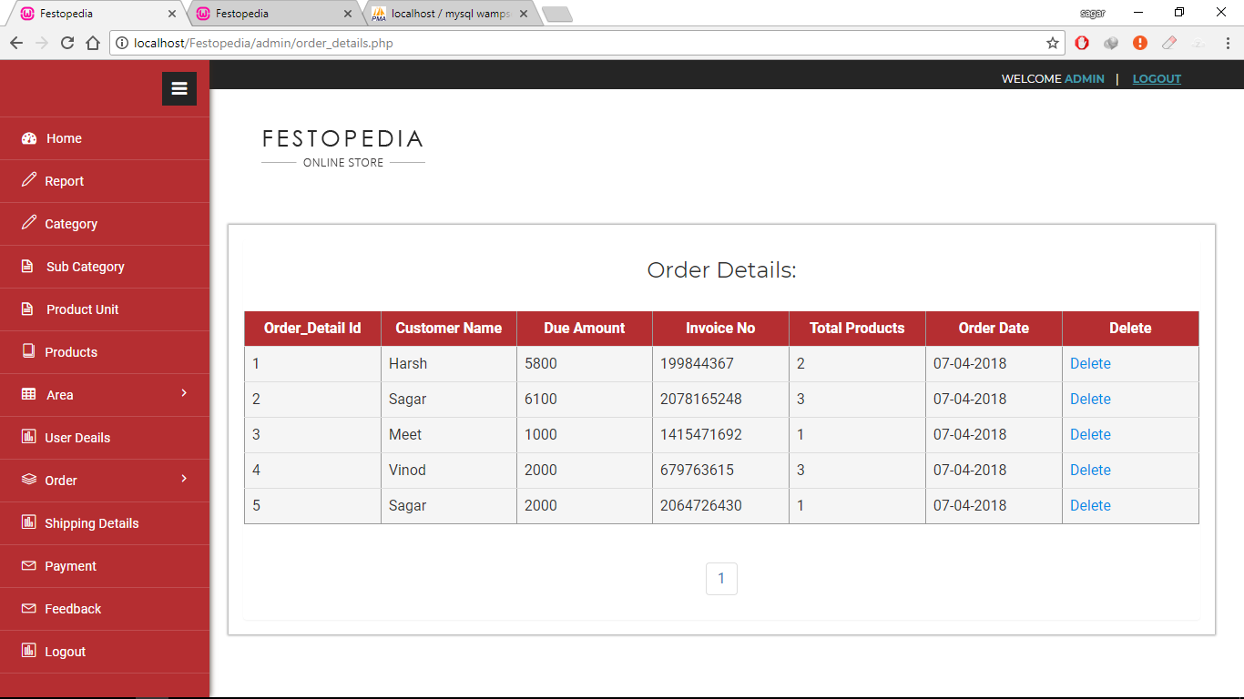

* This screenshot displays all order details of customer.
* **Shipping Details:**

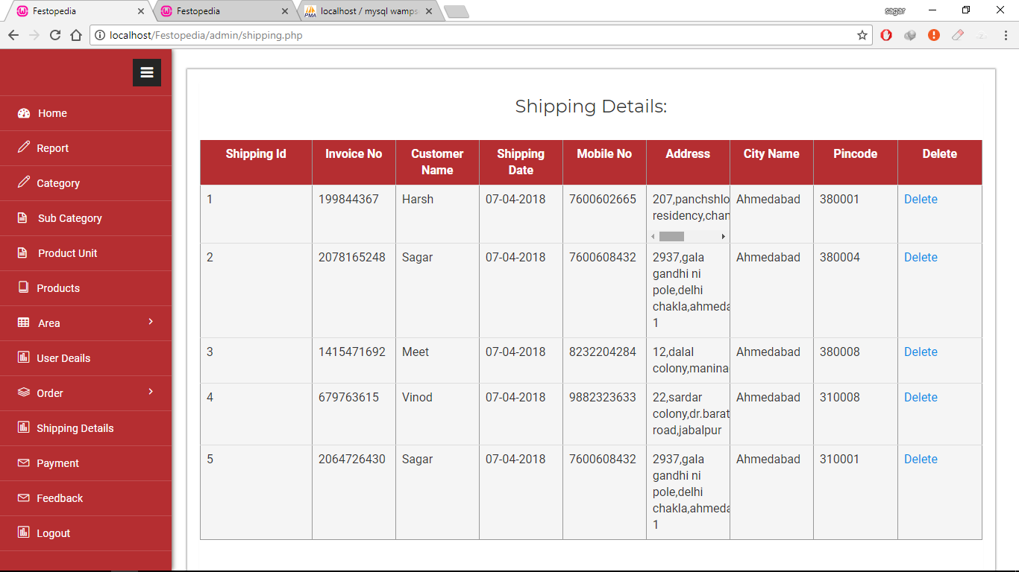

* This screenshot displays all shipping details of customer.
* **Payment Details:**

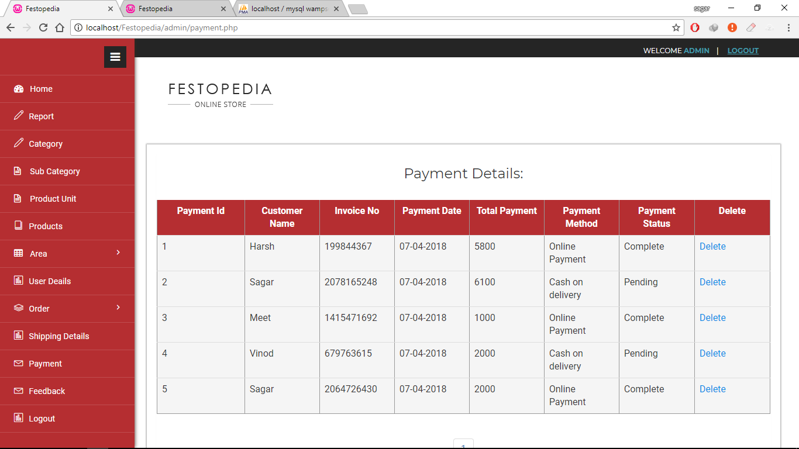

* This screenshot displays all payment details of customer.

1. **User Side :**

* **Home Page:**

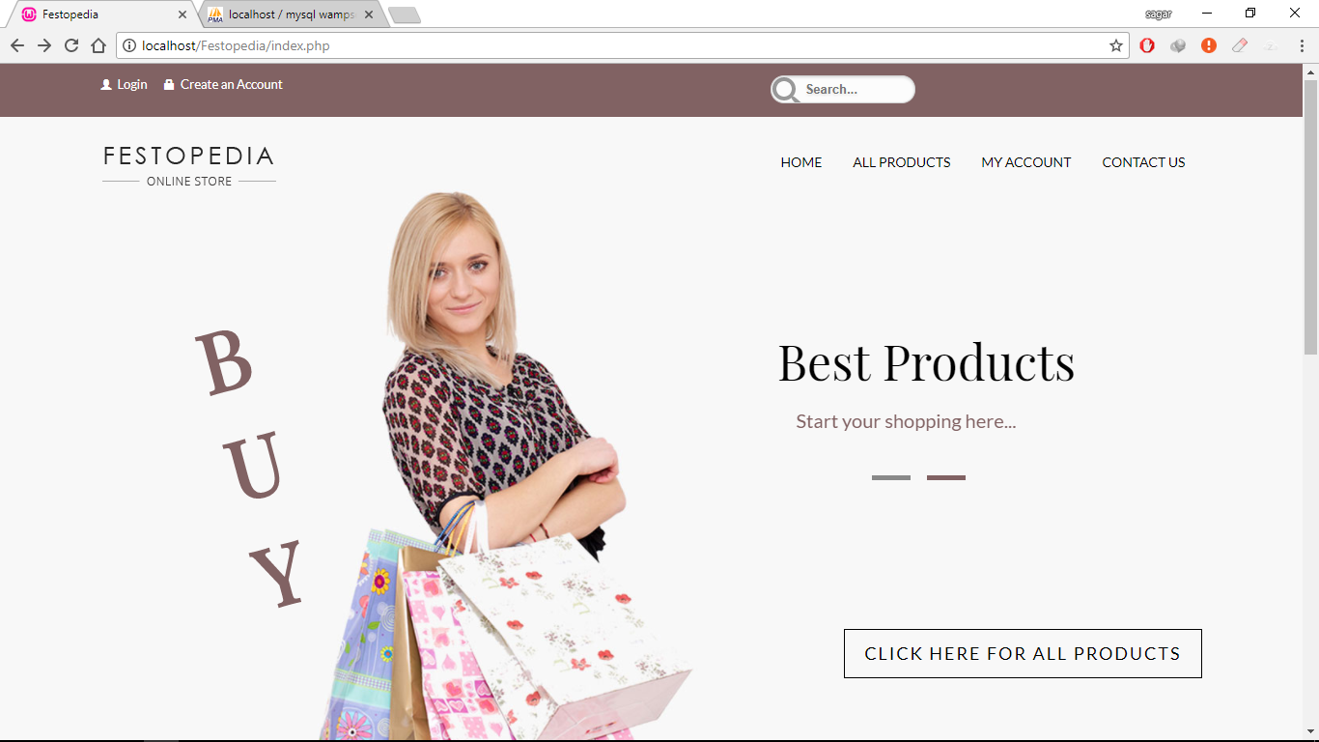

* This screenshot displays the home page of website.

.

* **Home Page:**

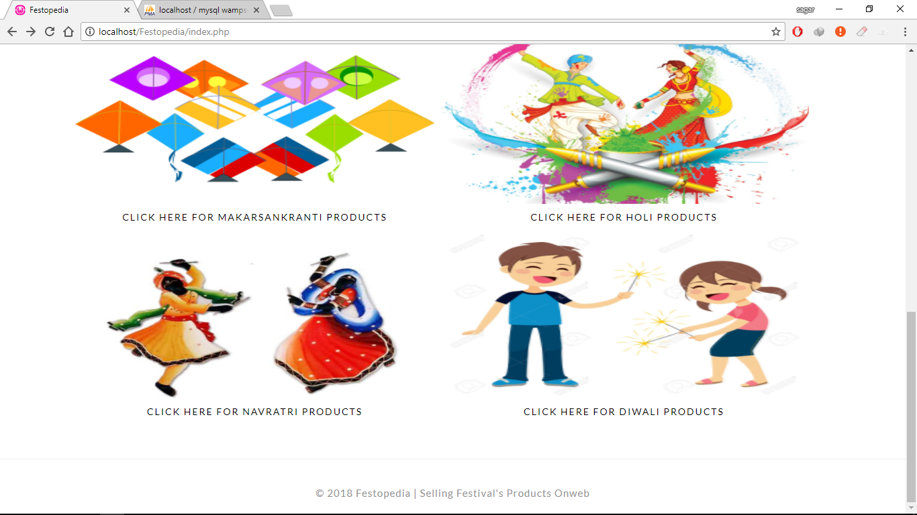

* This screenshot displays the home page of website.
* **Registration Page Validation:**

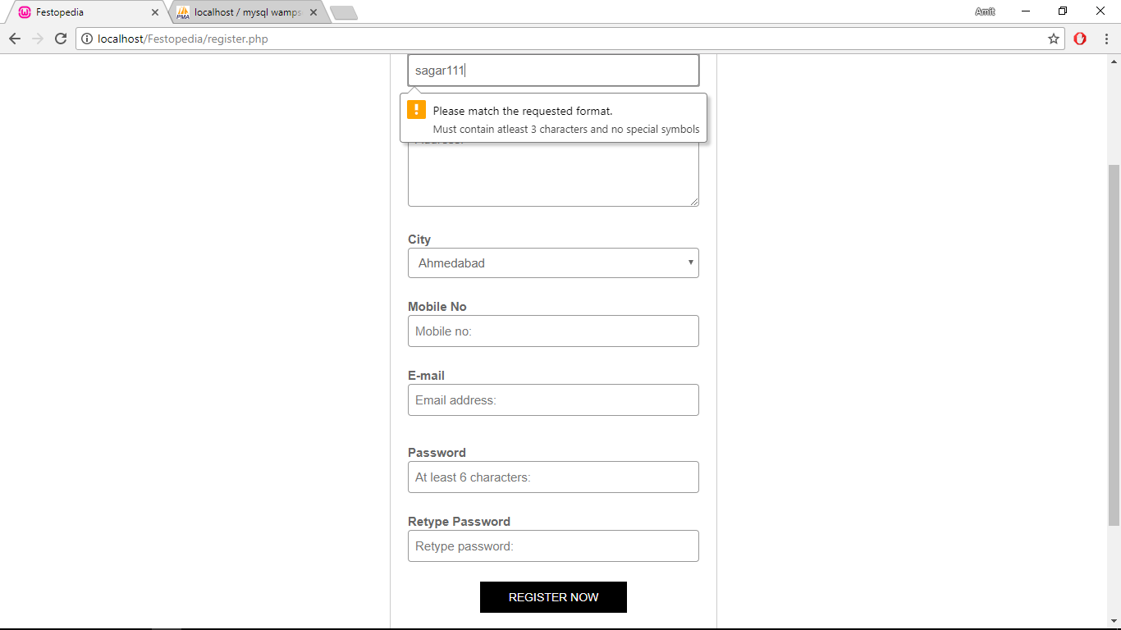

* This screenshot displays the validation in registration form.( web application checks and validate the registration form when user fillup the form).
* **Error Registration:**

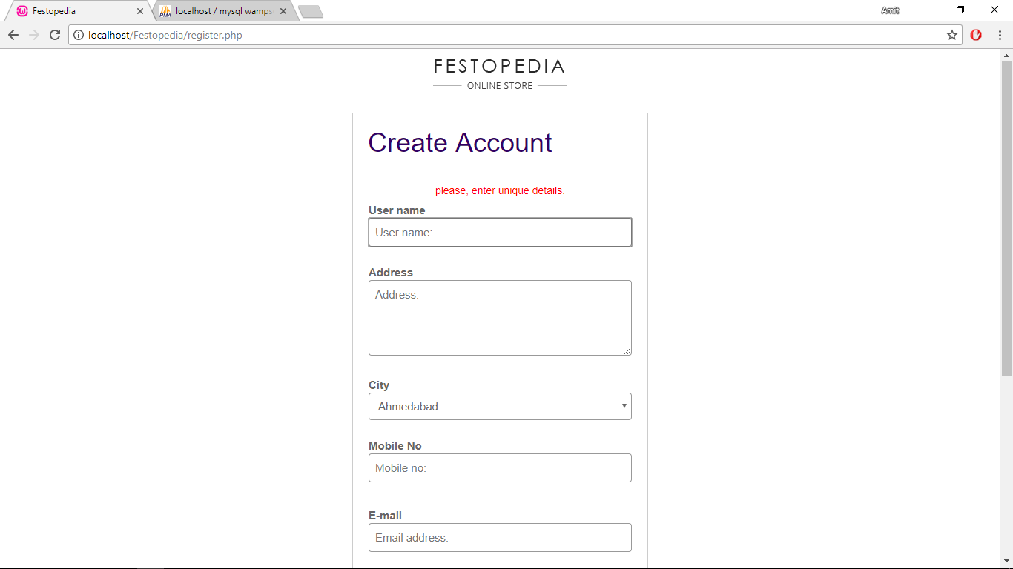

* This screenshot displays the error in registration form.( web application checks and validate the registration form when user fillup the form and display error message if any mistake found).
* **Success Registration:**

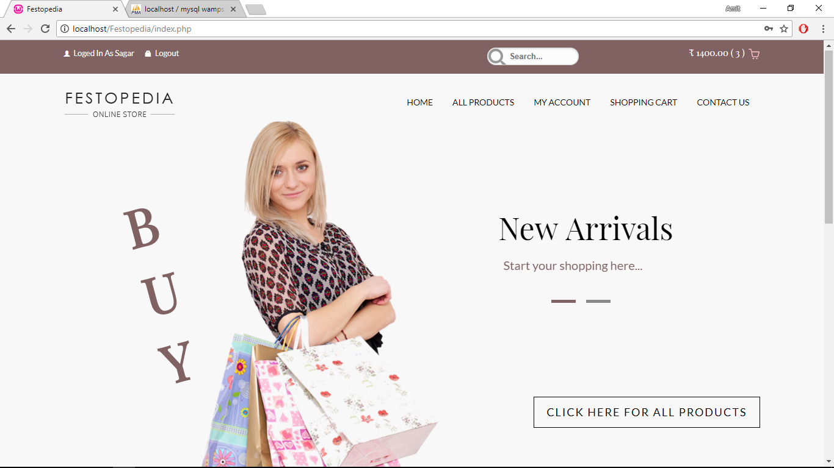

* This screenshot displays the home page(In web application when Customer enter all valid details and clicks on “Register” button , then Customer redirect on default page)..
* **Validation login page:**

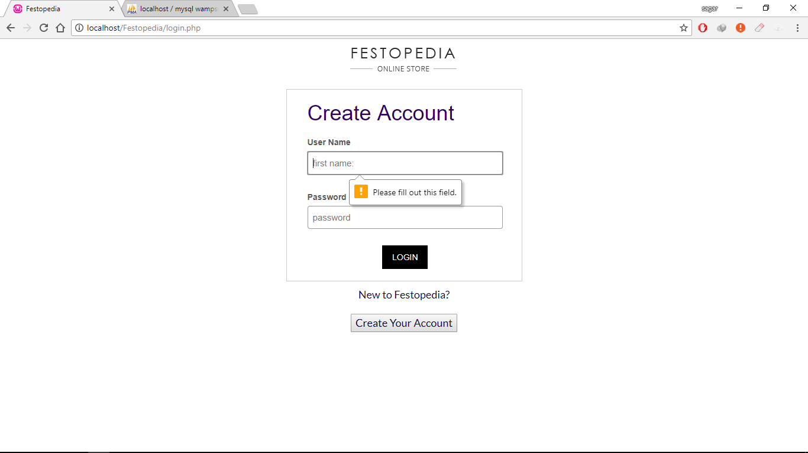

* This screenshot displays the validation in login form.( web application checks and validate the login form when user fillup the form).
* **Error login page:**

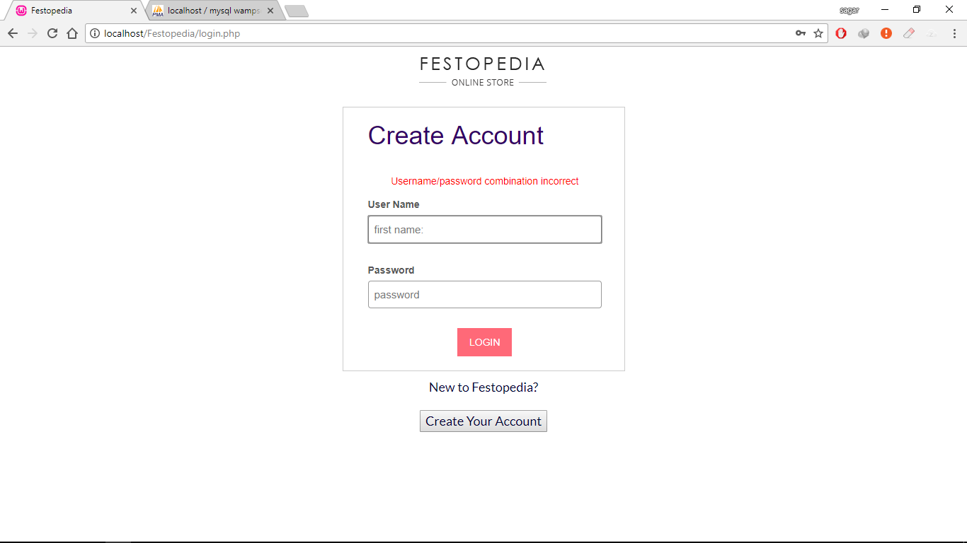

* This screenshot displays the error in login form.( web application checks and validate the login form when user fillup the form and display error message if any mistake found).
* **Success login page:**



* This screenshot displays the home page(In web application when Customer enter all valid details and clicks on “Login” button , then Customer redirect to default page).

* **All Products:**

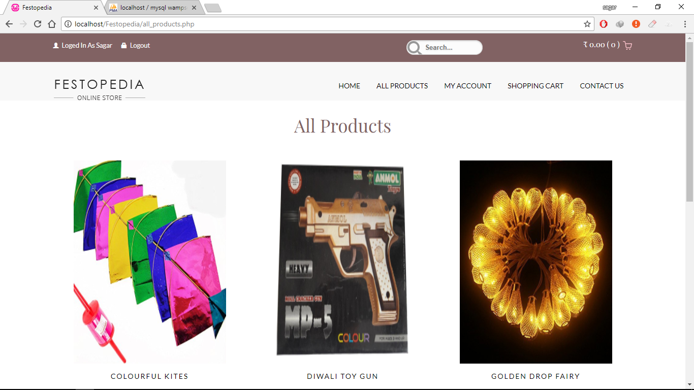

* This screenshot displays all products.
* **All Products:**

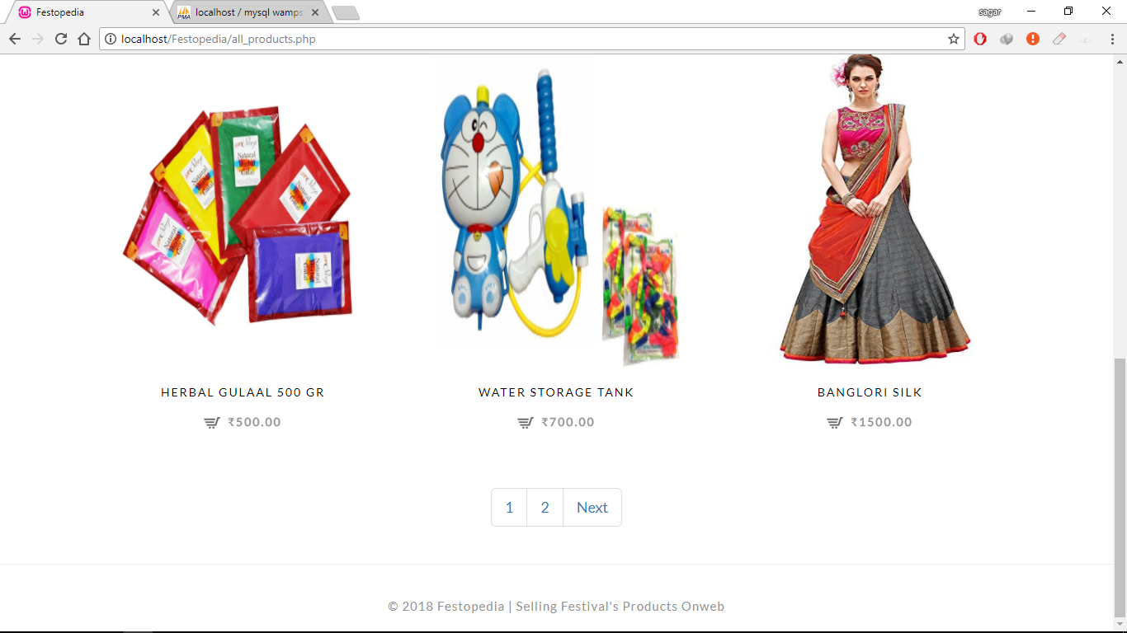

* This screenshot displays all products.
* **Product Details:**

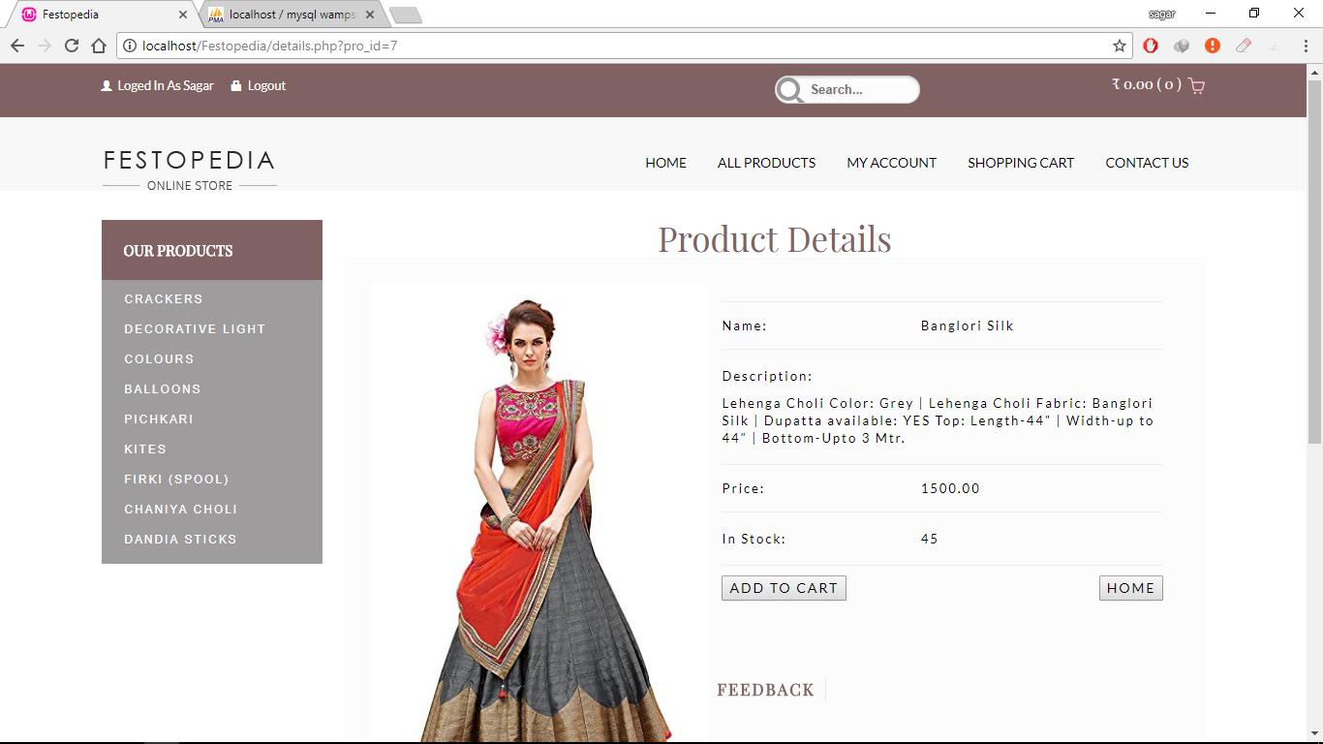

* This screenshot displays a product’s details.
* **User Feedback:**

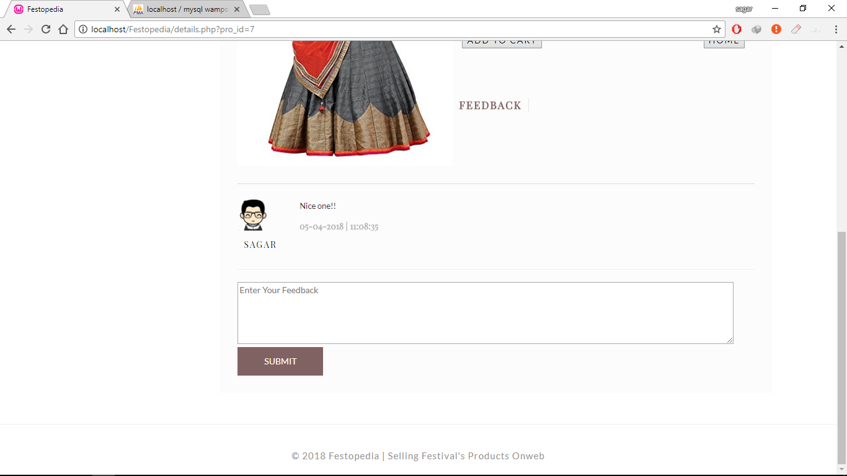

* This screenshot displays customers feedback on a product.
* **Add Product To Cart:**

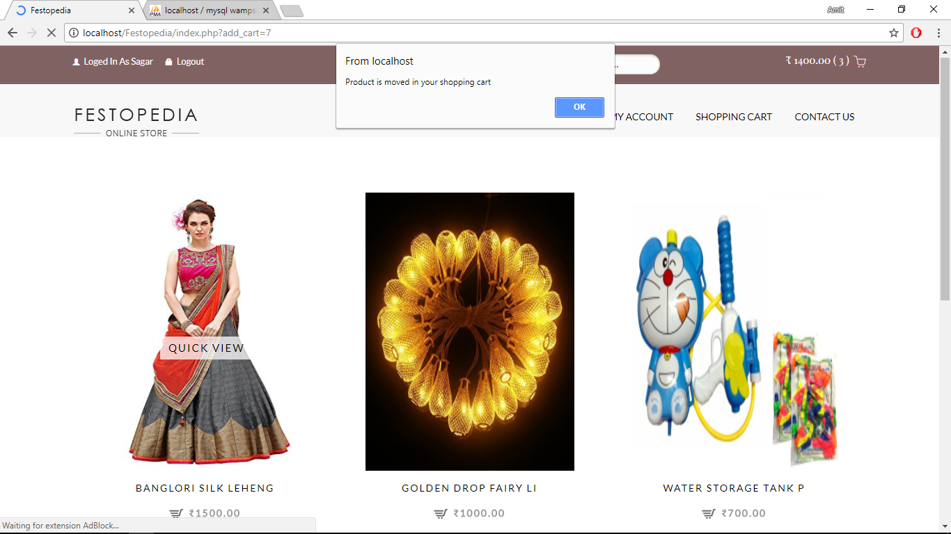

* This screenshot displays the alert message that “Product moved in your shopping cart”, it occurs when user click on product’s add to cart button.
* **Check Selected Product:**

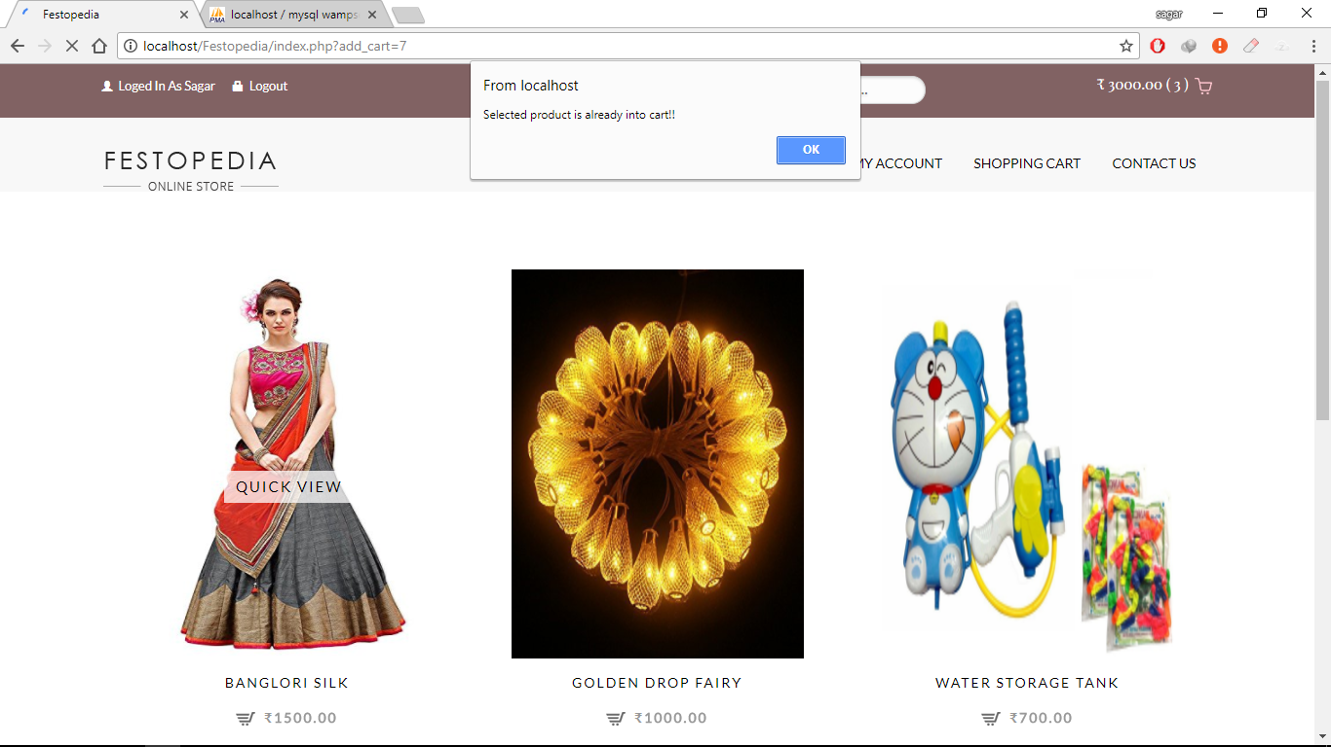

* This screenshot displays the alert message that “Selected product is already into cart” , it occurs when user click on product’s add to cart button and product is already into cart.
* **View Cart Items:**

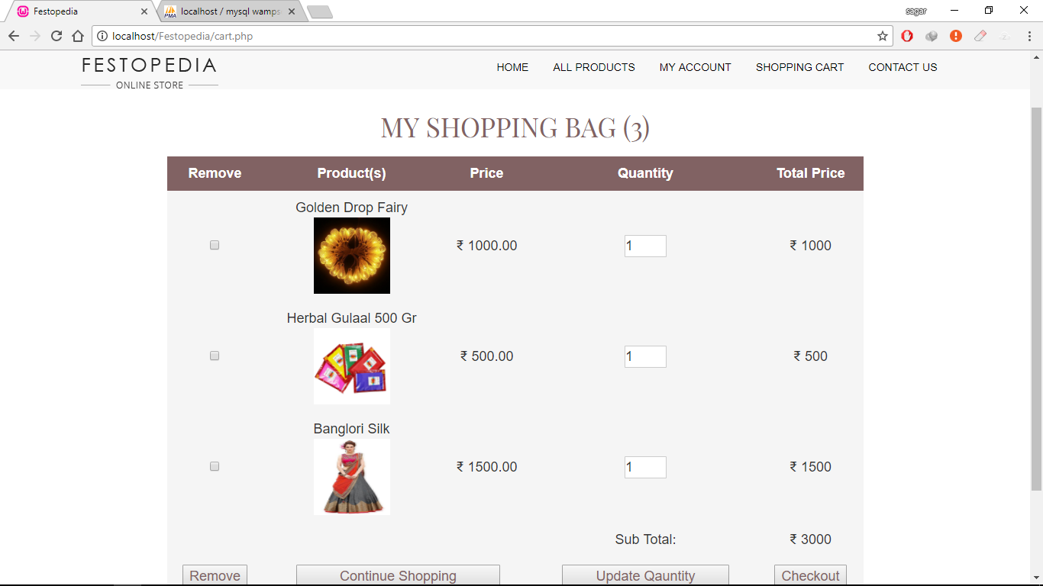

* This screenshot displays a Customer’s cart products.
* **Remove Cart Item:**

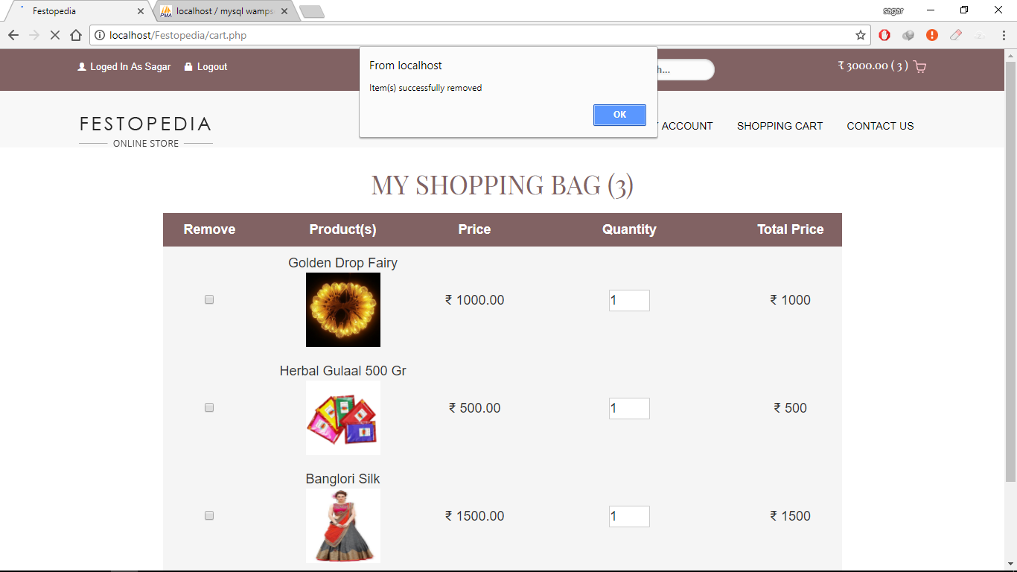

* This screenshot displays the alert message that “Item(s) successfully removed”, it occurs when user clicks on remove button.
* **Check Product’s Quantity:**

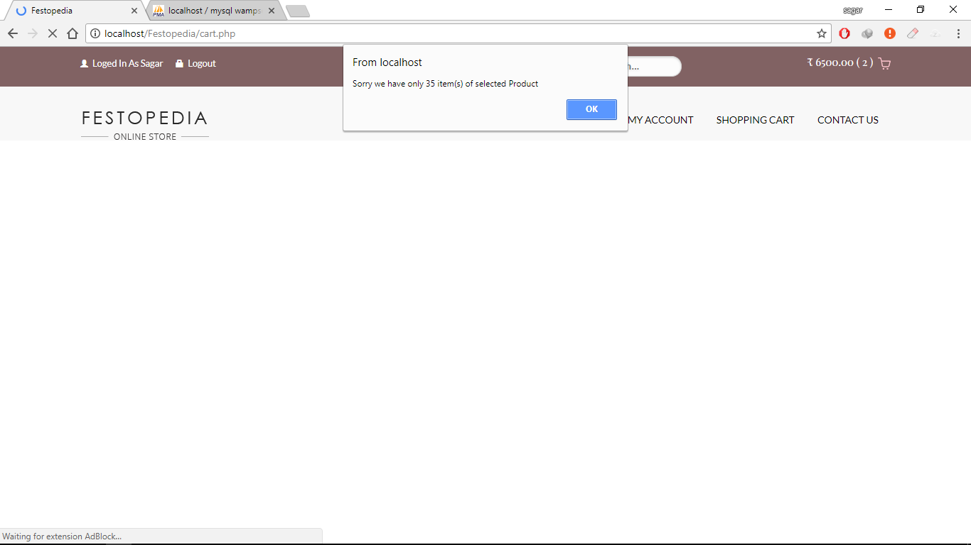

* This screenshot displays the alert message that “Sorry we have only 35 item(s) of selected product”, it occurs when user clicks on update quantity button.
* **Shipping Information:**

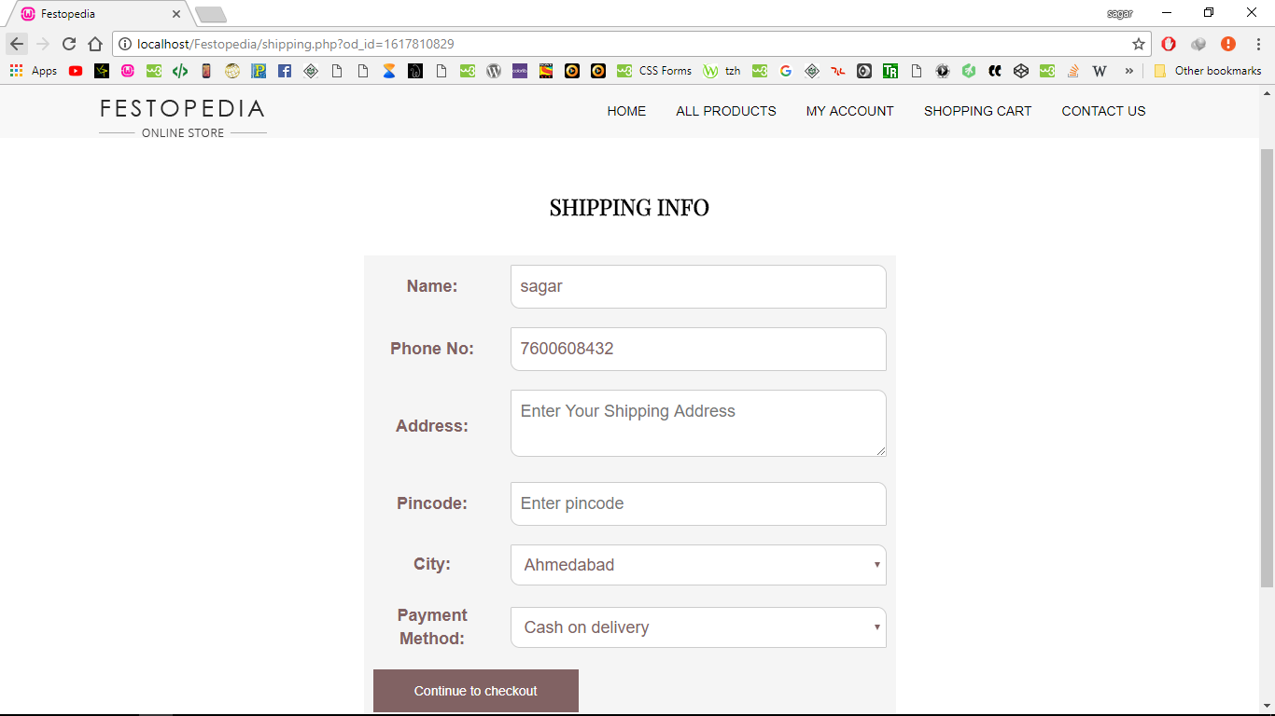

* This screenshot displays the shipping form.
* **Validate Shipping Details:**

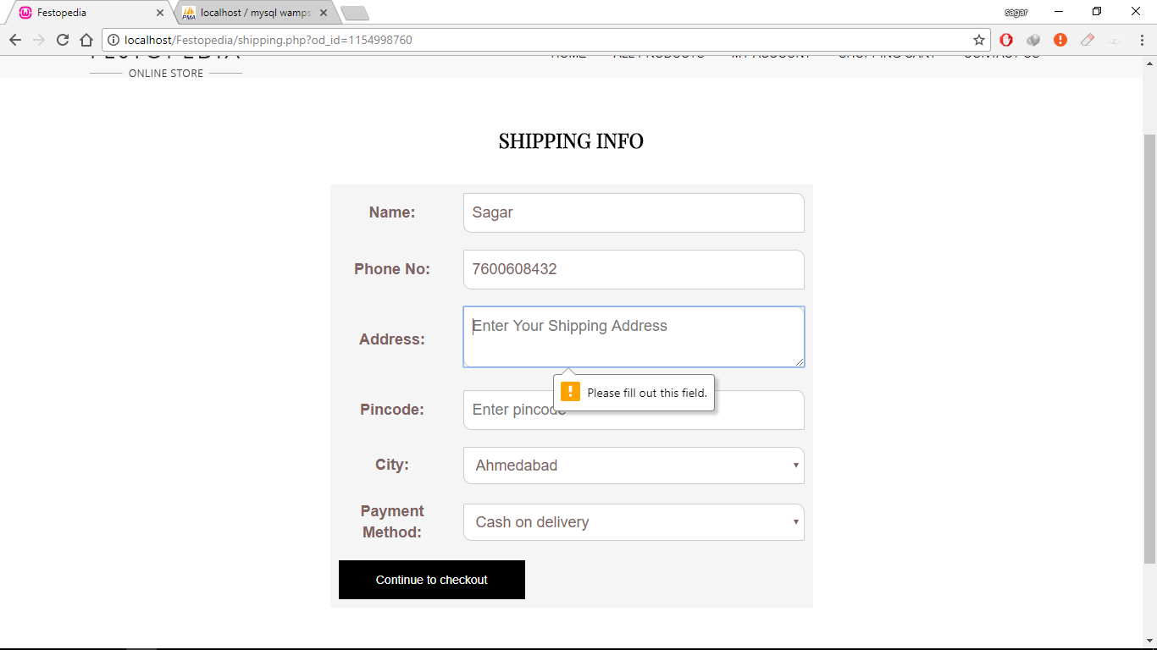

* This screenshot displays validation in shipping form.
* **Error Shipping Details:**

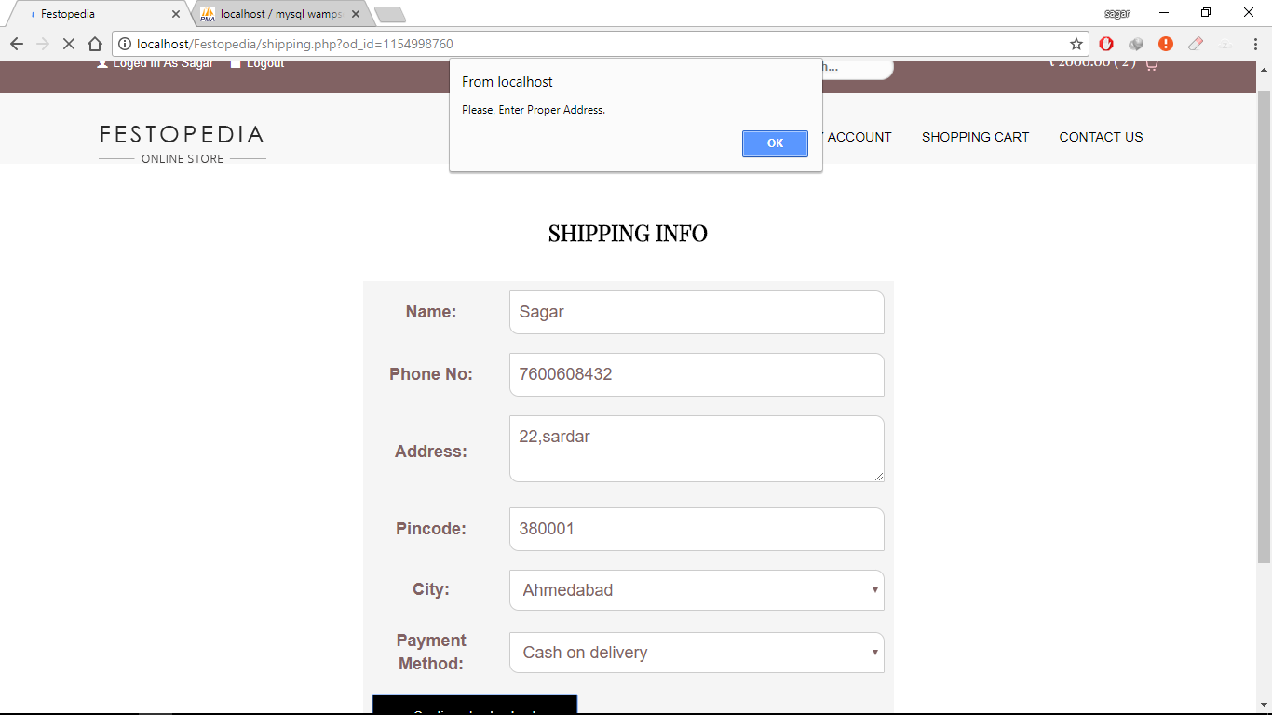

* This screenshot displays alert message in shipping form, it occurs when Customer enters wrong details.
* **Manage Account:**

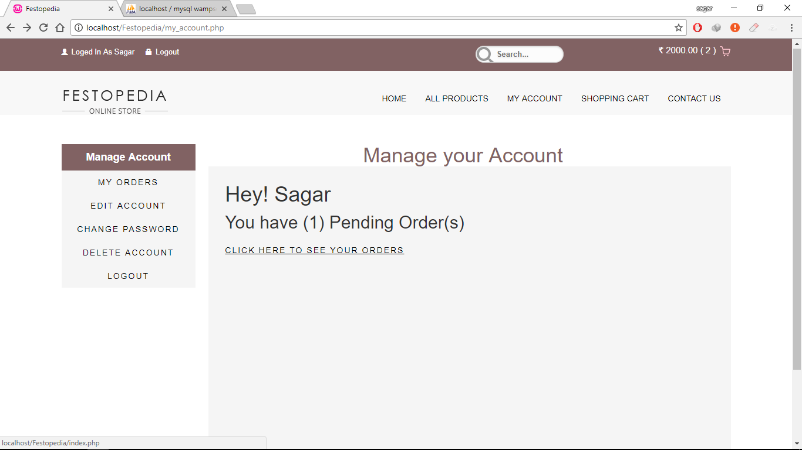

* This screenshot displays form which manage Customer’s account.
* **Order Details:**

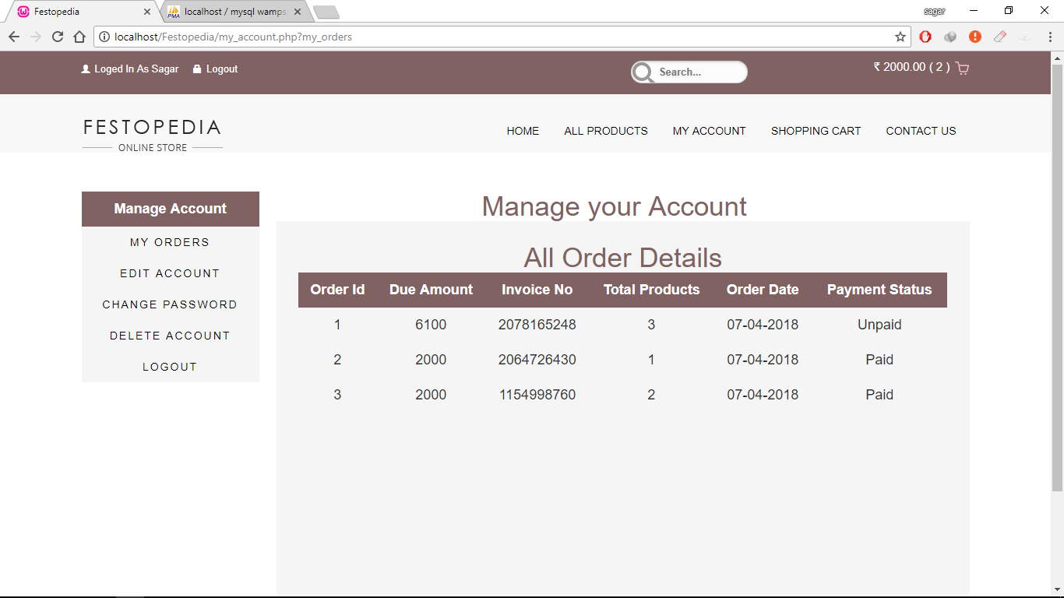

* This screenshot displays Customer’s all order details.
* **Edit Account:**

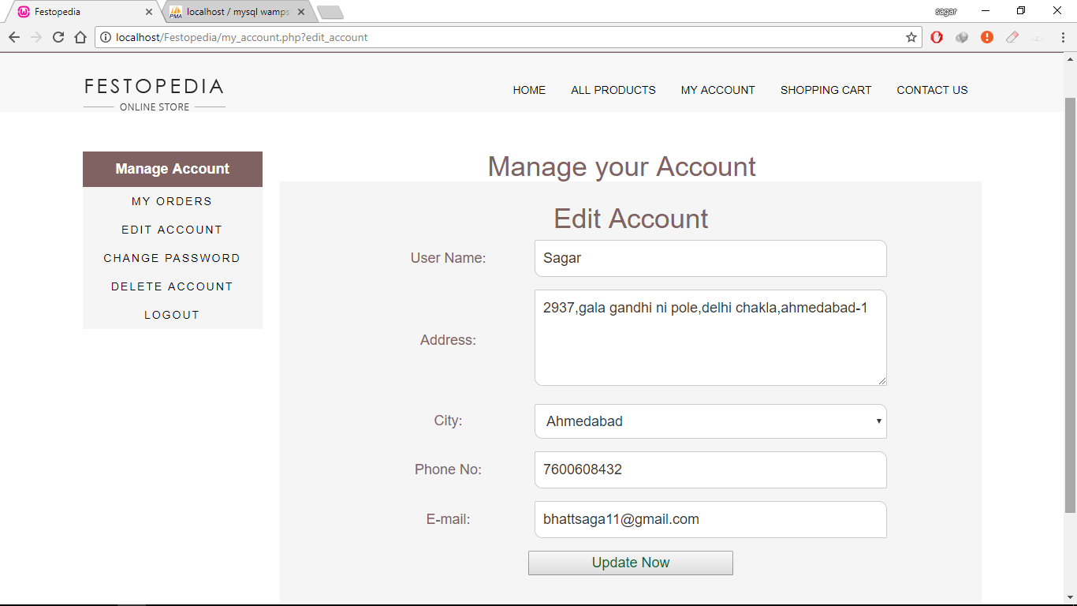

* This screenshot displays edit account form and Customer can edit his/her account details.
* **Change Account Password:**

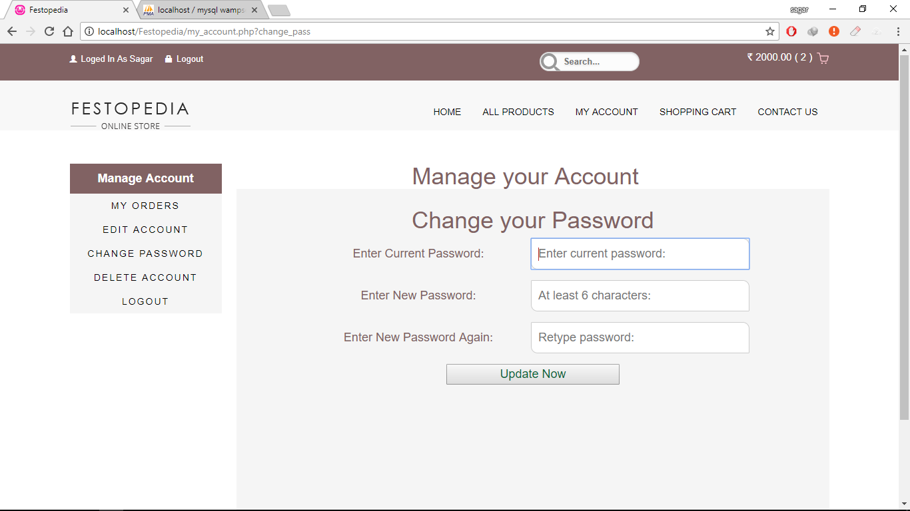

* This screenshot displays change account password form and Customer can change his/her account password.
* **Delete Account:**

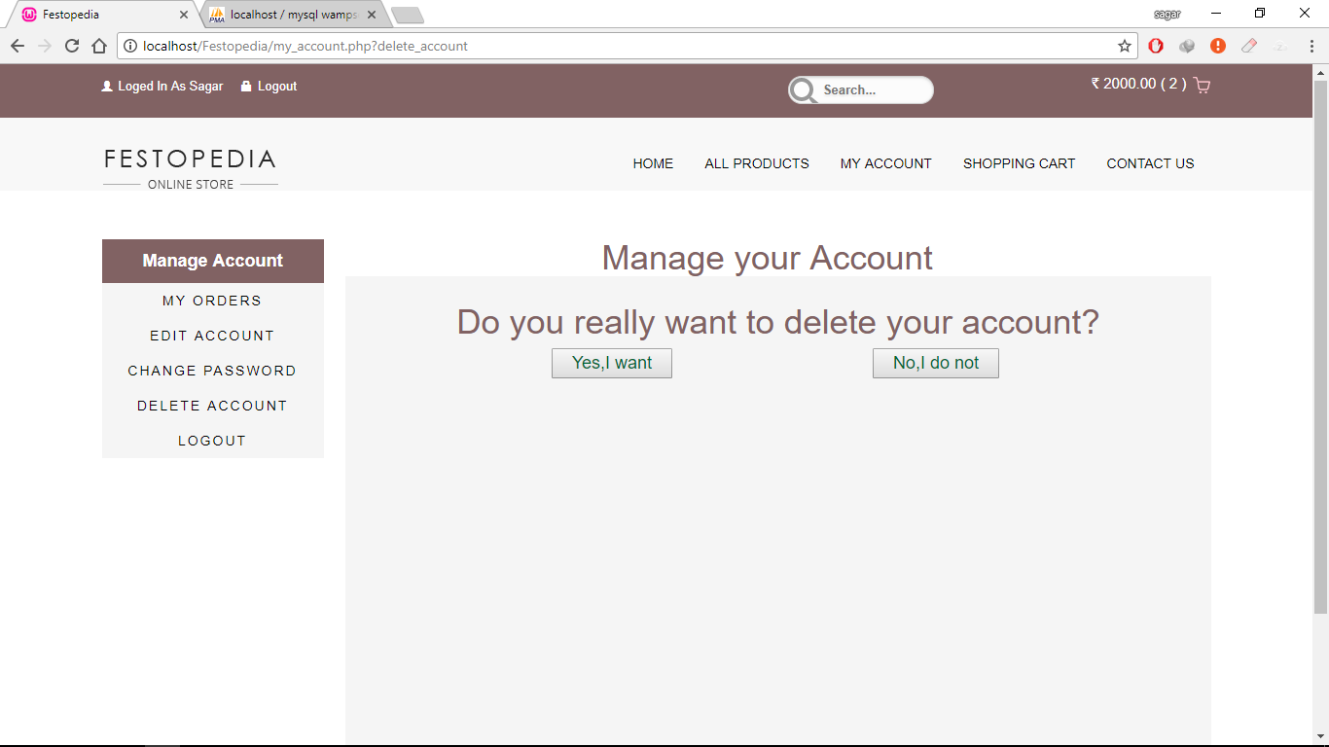

* This screenshot displays delete account form and Customer can delete his/her account.
* **Confirmation for Delete:**

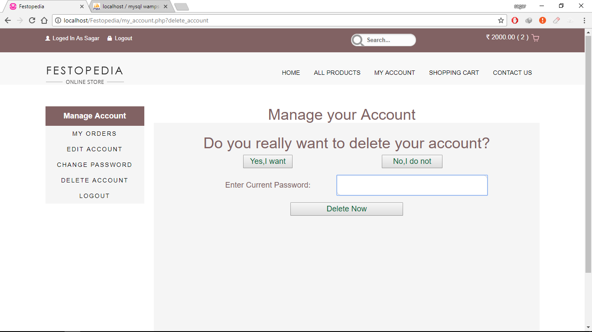

* This screenshot displays delete account form and Customer can delete his/her account, it asks Customer to enter current password to delete account.
* **Contact Us Page:**

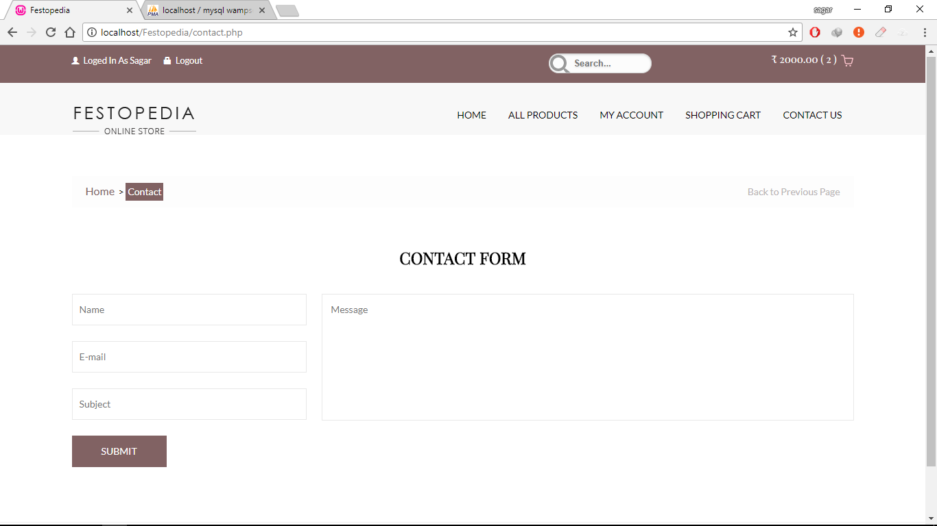

* This screenshot displays contact us form.

Report Layout

* **Customer Report By City:**

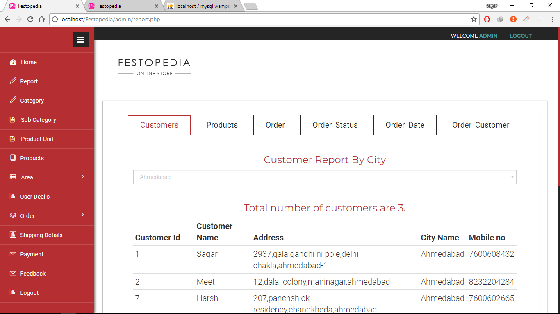

* This screenshot displays Customer report by city and display total number of Customers.
* **Customer Report By City:**

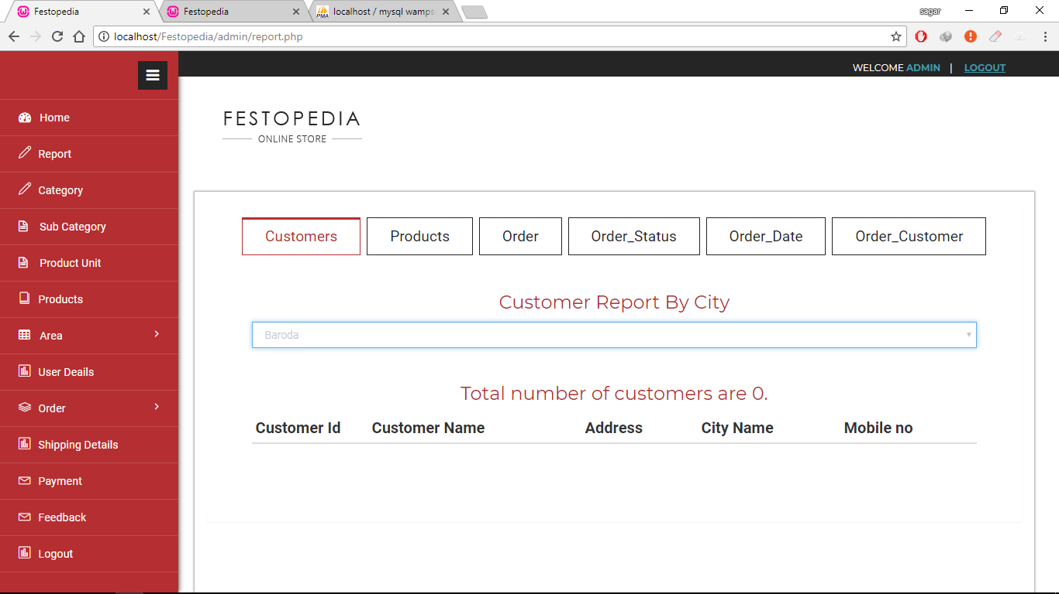

* This screenshot displays Customer report by city and display total number of Customers.
* **Customer Report By City:**

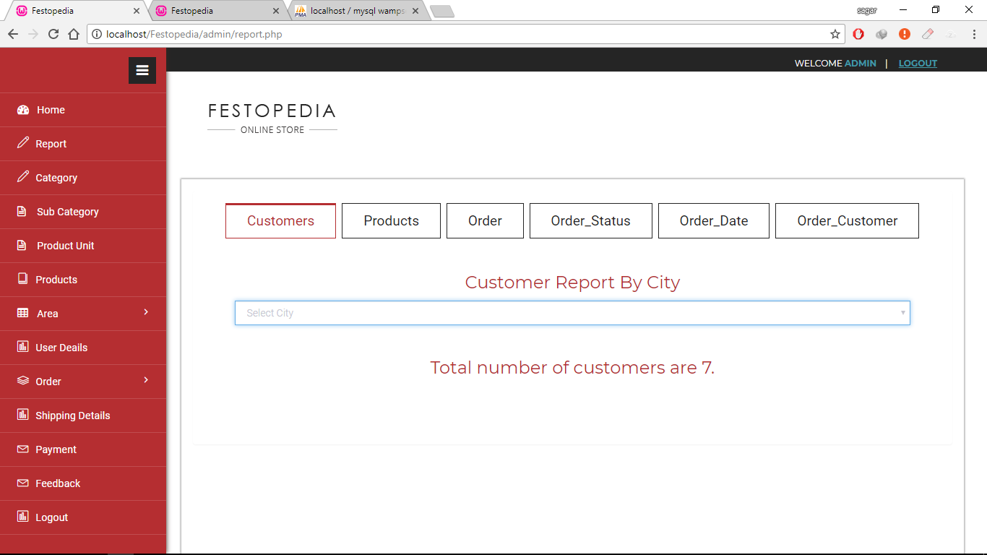

* This screenshot displays Customer report by city and display total number of Customers.
* **Product Report By Category:**

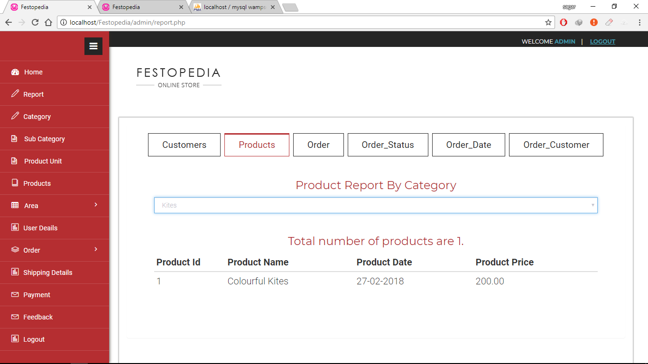

* This screenshot displays product report by category and display total number of products.
* **Order Report By Product:**

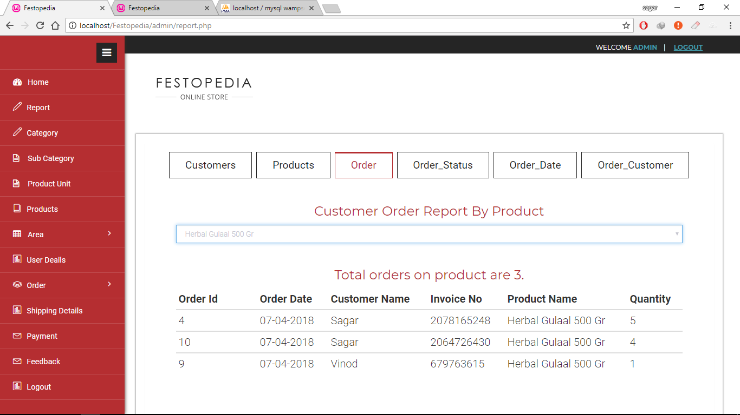

* This screenshot displays order report by product and display total number of orders on a product.
* **Order Report By Order Status:**

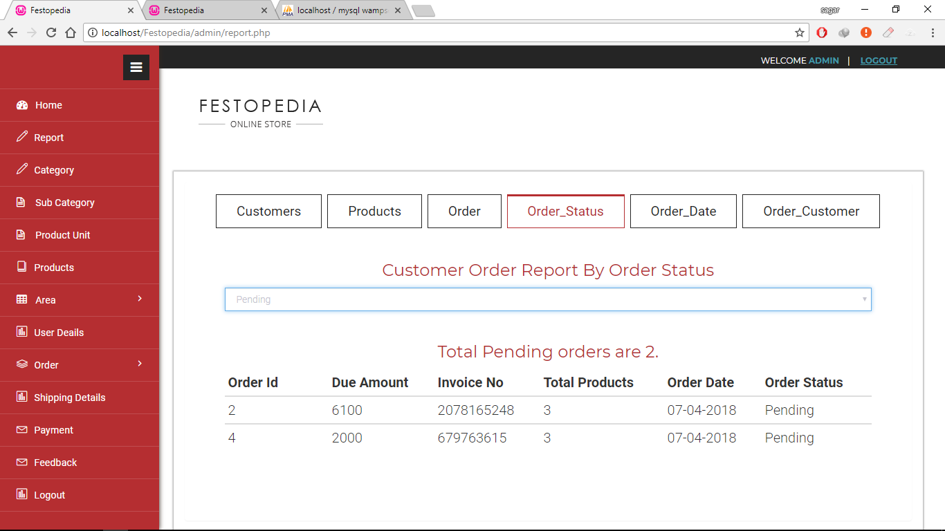

* This screenshot displays order report by order status and display total number of orders according to pending and complete status.
* **Order Report By Date:**

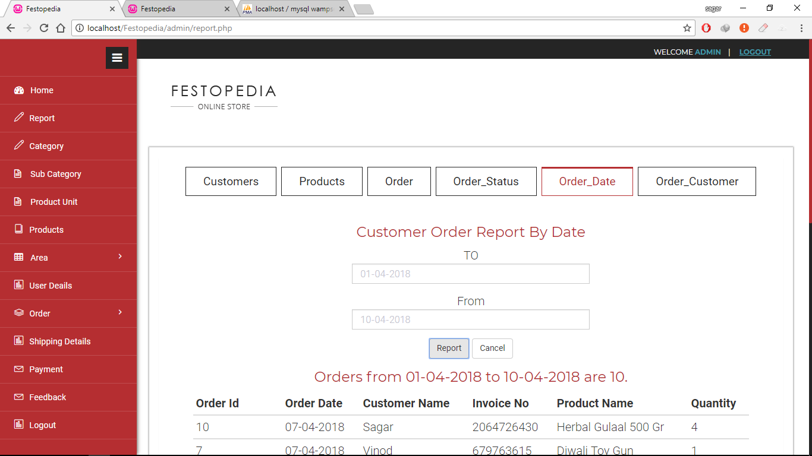

* This screenshot displays order report by order date and display total number of orders between selected dates.
* **Order Report By Customer:**

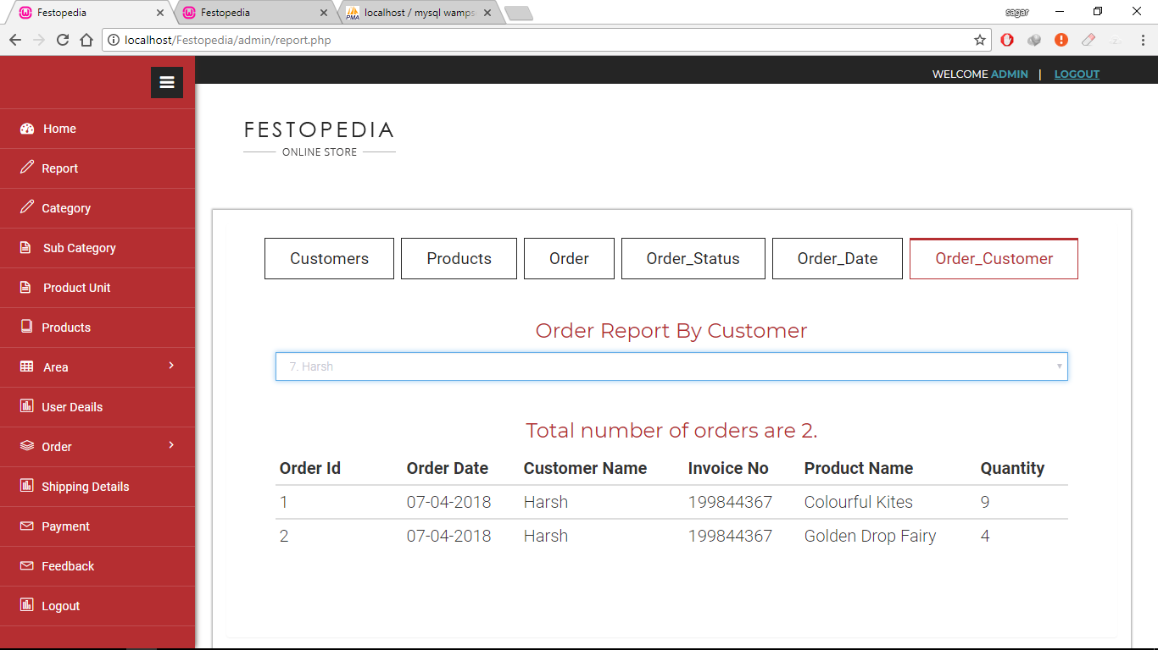

* This screenshot displays order report by Customer and display total number of orders given by a Customer.

Future Enhancement

1. **Future Enhancement :**

* For future development I had planned for developing this application for mobile user. Because of nowadays there are so many users who are using mobile for surfing.
* Nowadays there are much users they are using mobile. I am making plan to create this application for mobile users. For creating this application so many user are become much easy for using this application.
* The development of mobile site was started but because of lack of time I could not complete it, so I am planning to develop it as mobile users.
* The text messages to companies and it’s employee about latest updates in the IT world can be given.
* More functions can be added in future.
* In future, the system may be expanded and more modules can be added and integrated with the current system.

Conclusion

1. **Conclusion :**

* It is an important that your knowledge by applying techniques to real life situations. And this is achieved through a simulated project.
* We hope that system will meet all system objectives and fulfil all requirements of user.
* The entire system is interactive and system is able to process and generate reports.
* The successful completion of project resulted in:
* Faster Data Processing and reduces repetitive work.
* Less efforts and faster desired output.
* The project has been conclude keeping in new all the needs and requirements of system.

Bibliography

1. **Bibliography :**

* For the successful working of my project we have referred many sources for the code snippets, logics and tips n tricks from the various book as well as website.
* Most I searched for the required possessions on the google.com search engine..

**Books:**

*Developing Web Applications in PHP and AJAX*

*Teach yourself PHP,MySQL and Apache*

**Web sites:**

[*www.google.co.in*](http://www.google.co.in)

## www.w3 Schools.com

## www.youtube.com

